Test Case: tc001_SPX_Dev5_Validar_Campos_Proceso_Nuevo_Articulos_Almacen
Step 1 - Enter username and password and click to button Enter : Credentials Entered
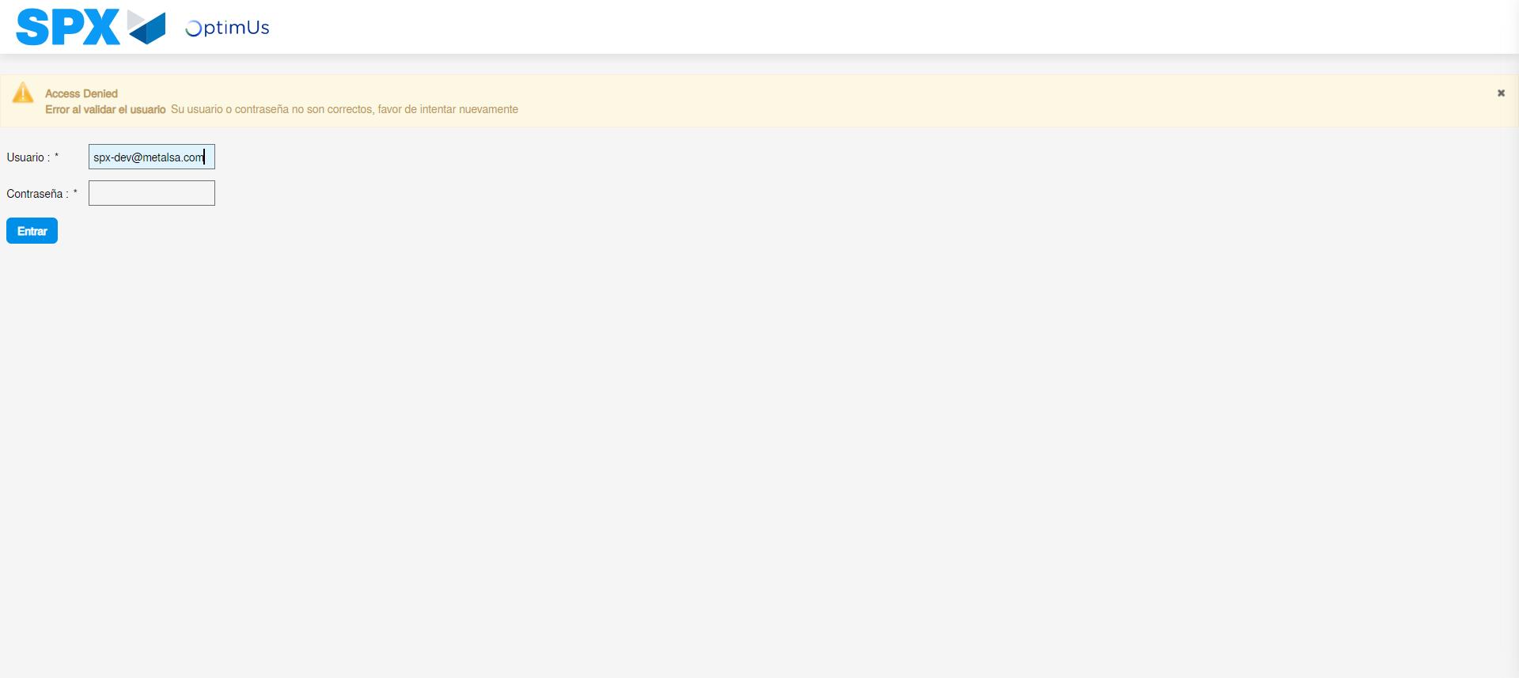Image file-name: QC_Testing-tc001_SPX_Dev5_Validar_Campos_Proceso_Nuevo_Articulos_Almacen-may. 16 2024, 06 53 28 p. m.

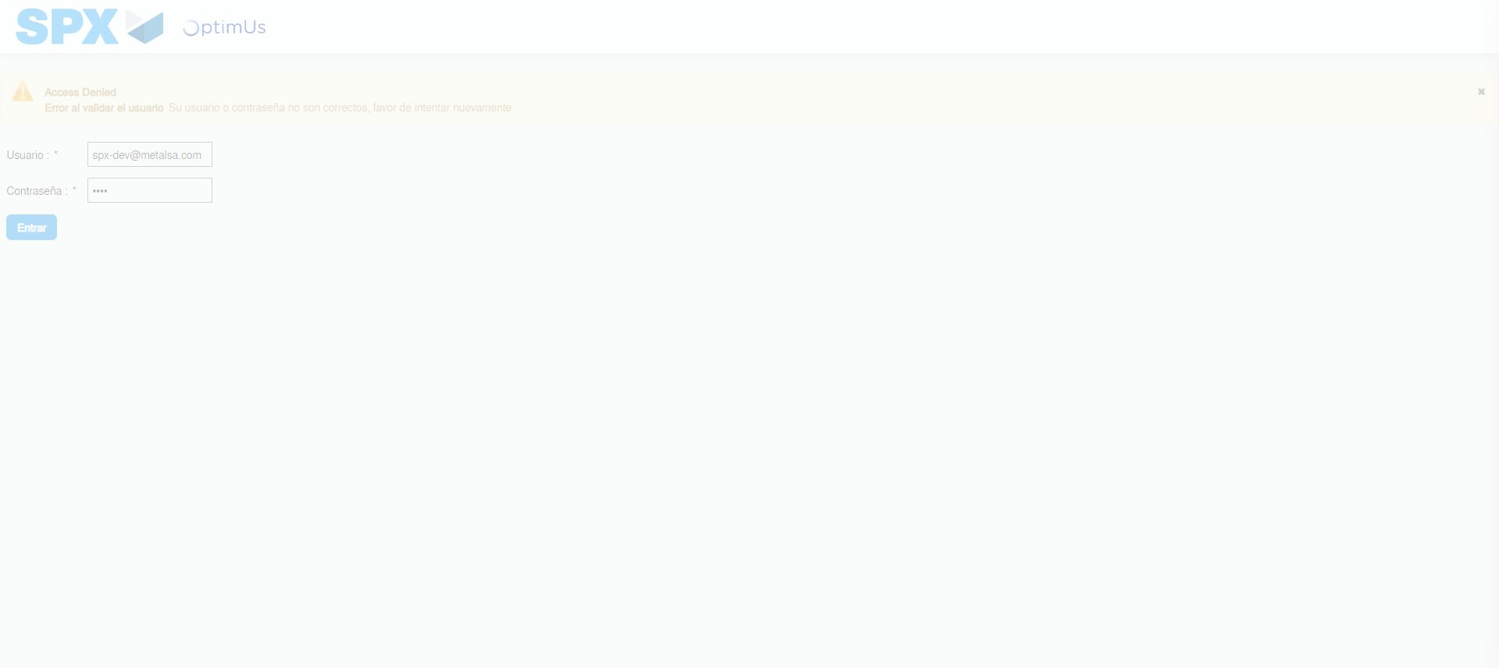Image file-name: QC_Testing-tc001_SPX_Dev5_Validar_Campos_Proceso_Nuevo_Articulos_Almacen-may. 16 2024, 06 53 29 p. m.

Image file-name: QC_Testing-tc001_SPX_Dev5_Validar_Campos_Proceso_Nuevo_Articulos_Almacen-may. 16 2024, 06 53 30 p. m.

Step 2 - Select to UEN and Access to Articulos por Procesar: UEN Correctly selected and Correct access
Image file-name: QC_Testing-tc001_SPX_Dev5_Validar_Campos_Proceso_Nuevo_Articulos_Almacen-may. 16 2024, 06 53 33 p. m.

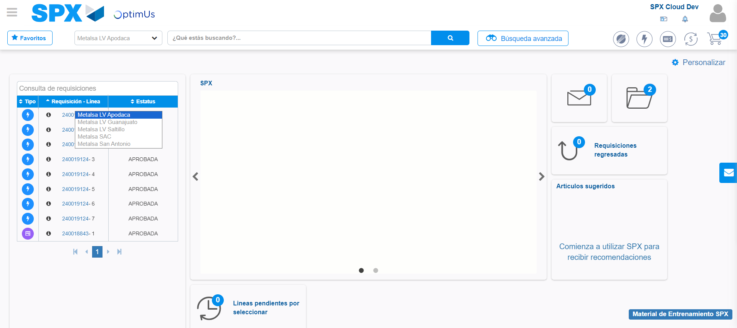Image file-name: QC_Testing-tc001_SPX_Dev5_Validar_Campos_Proceso_Nuevo_Articulos_Almacen-may. 16 2024, 06 53 36 p. m.

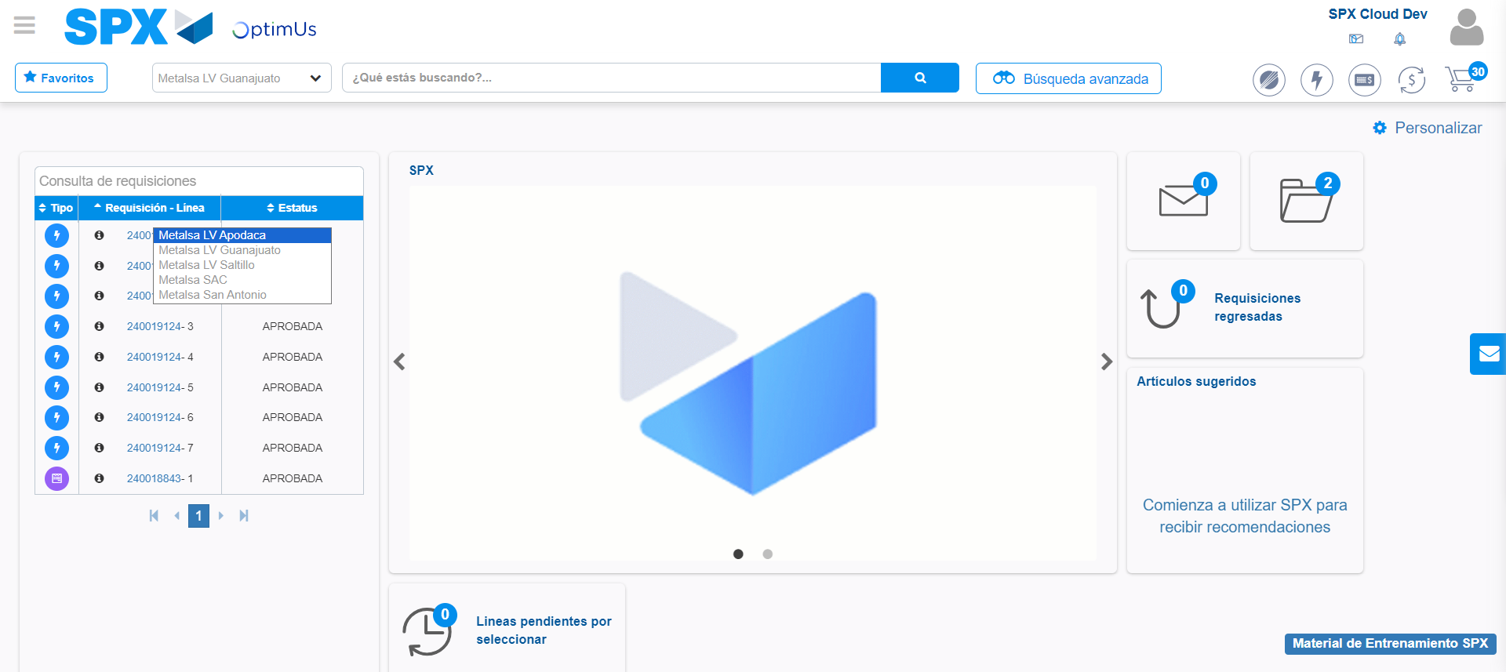Image file-name: QC_Testing-tc001_SPX_Dev5_Validar_Campos_Proceso_Nuevo_Articulos_Almacen-may. 16 2024, 06 53 37 p. m.

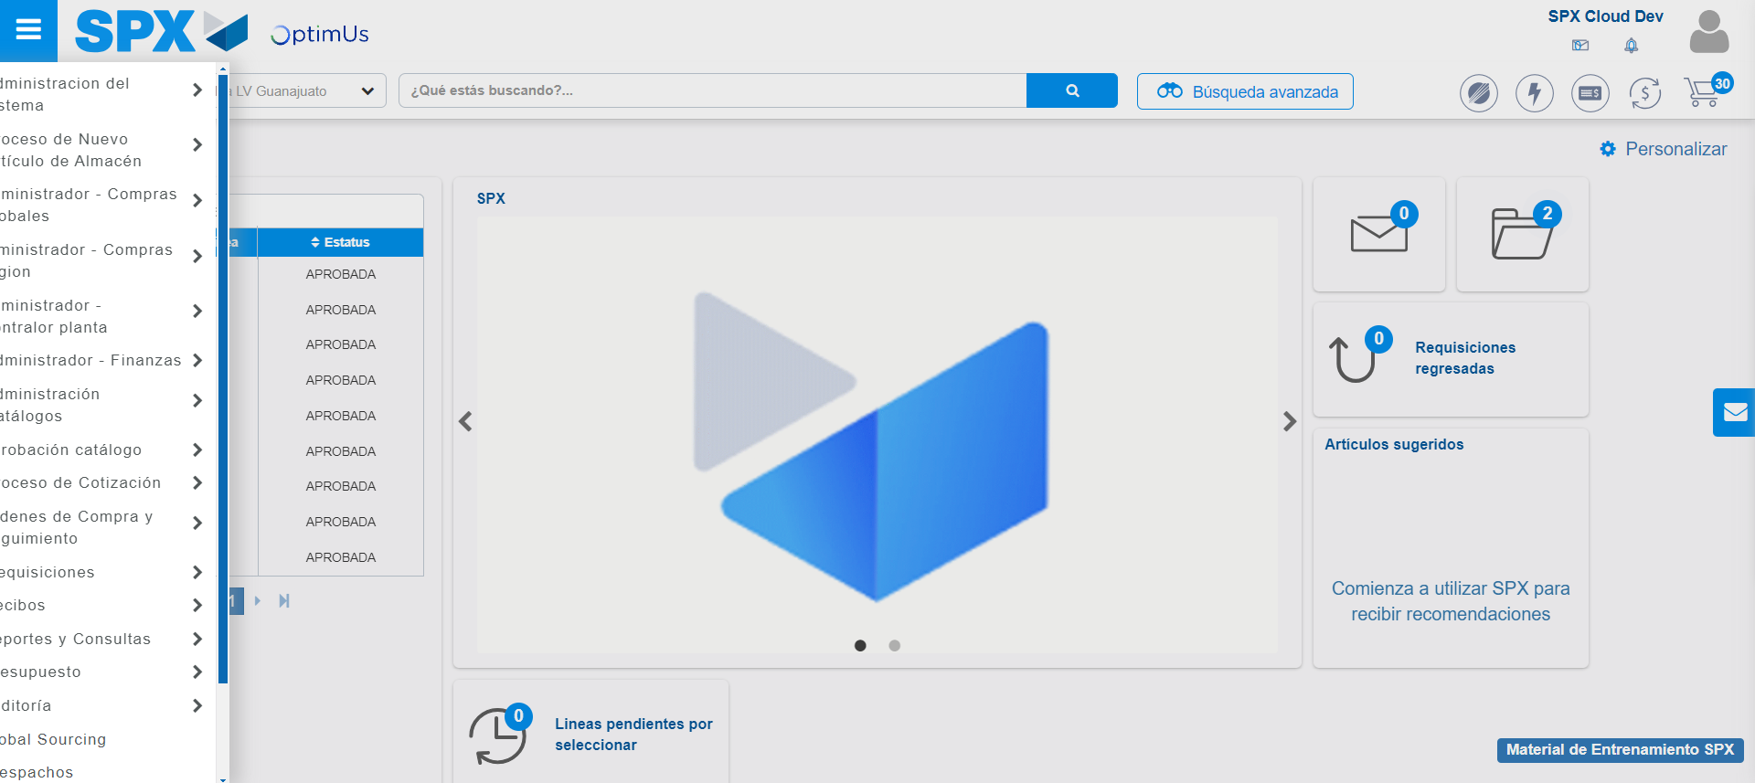Image file-name: QC_Testing-tc001_SPX_Dev5_Validar_Campos_Proceso_Nuevo_Articulos_Almacen-may. 16 2024, 06 53 38 p. m.

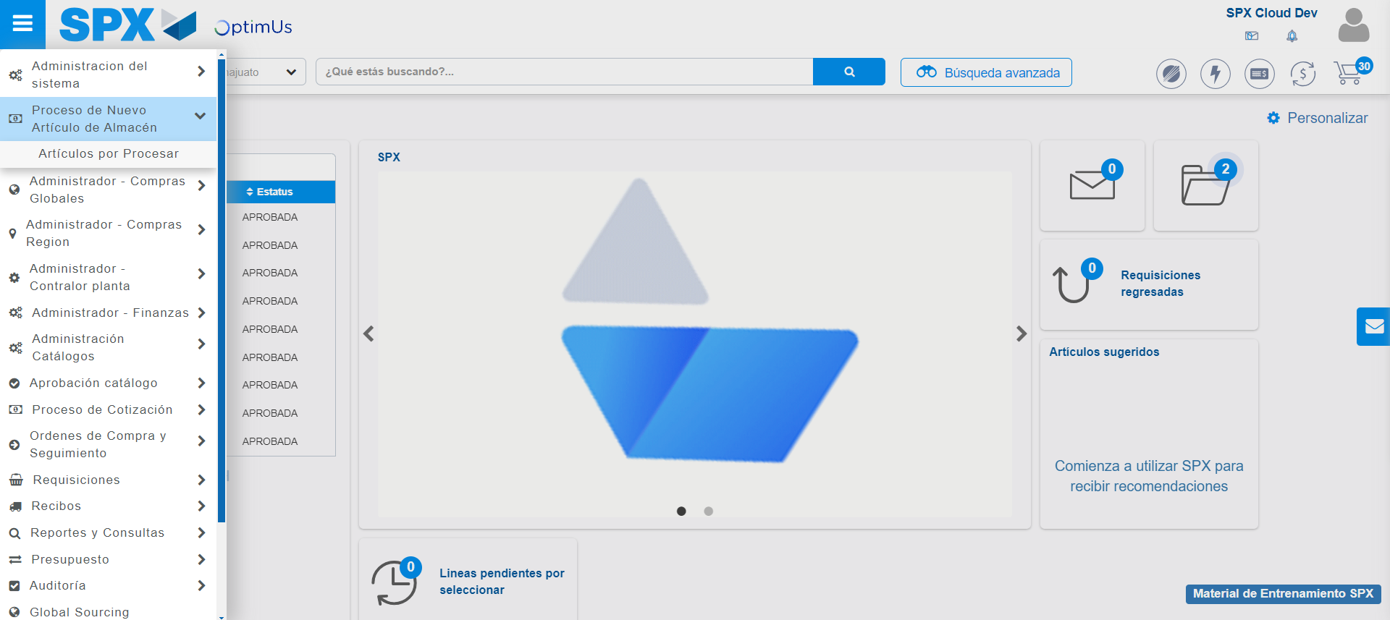Image file-name: QC_Testing-tc001_SPX_Dev5_Validar_Campos_Proceso_Nuevo_Articulos_Almacen-may. 16 2024, 06 53 39 p. m.

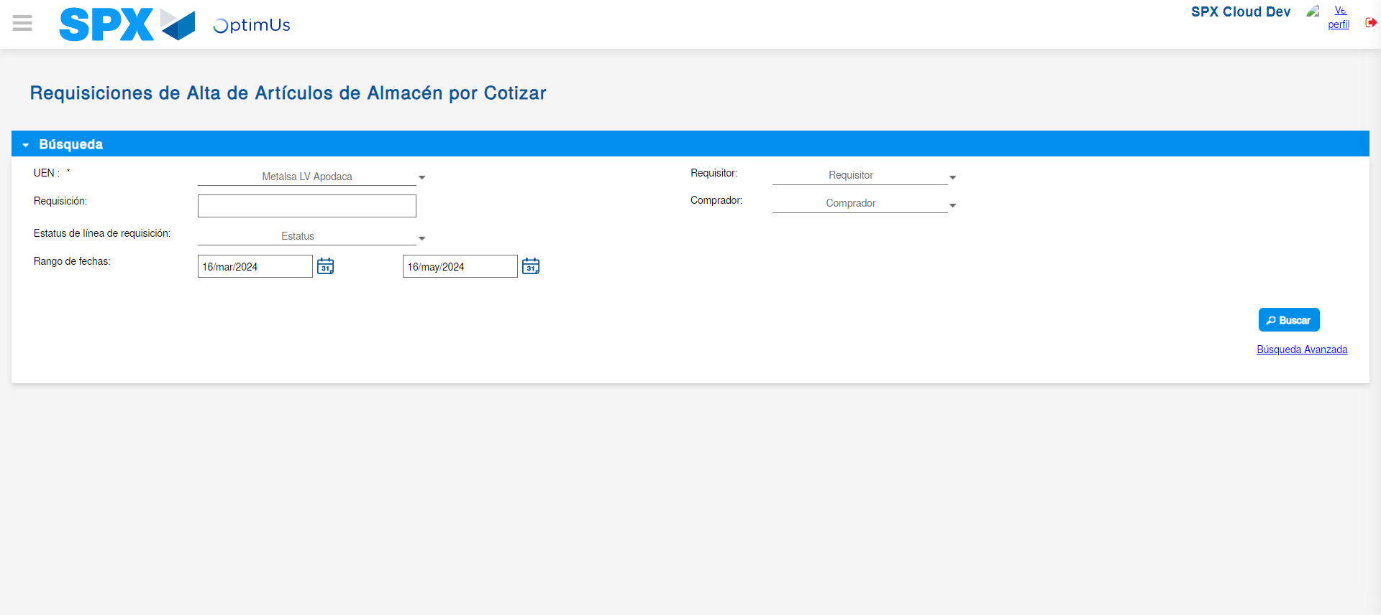Image file-name: QC_Testing-tc001_SPX_Dev5_Validar_Campos_Proceso_Nuevo_Articulos_Almacen-may. 16 2024, 06 53 44 p. m.

Step 3 - Validate search fields: Validated fields
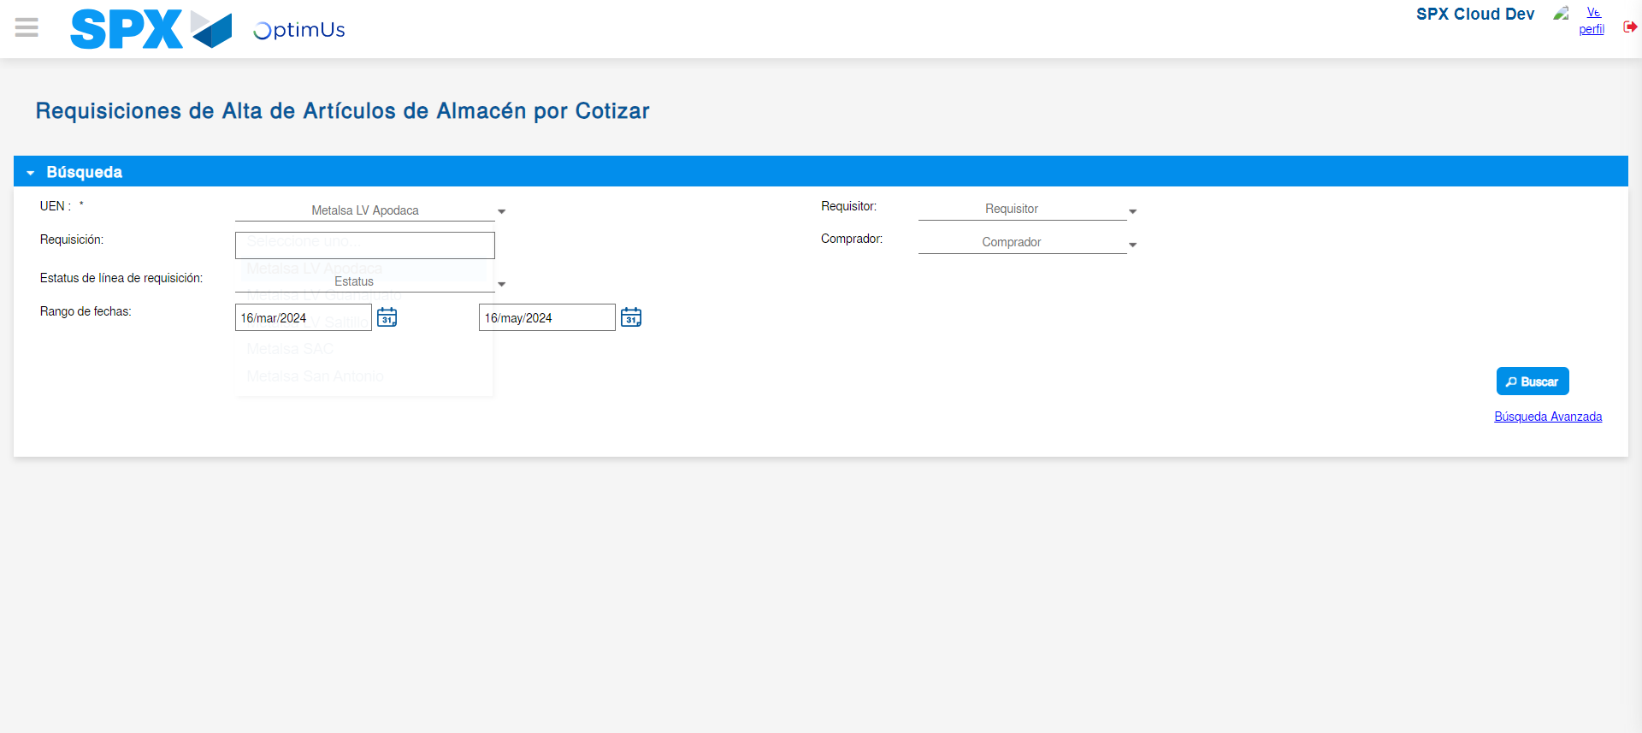Image file-name: QC_Testing-tc001_SPX_Dev5_Validar_Campos_Proceso_Nuevo_Articulos_Almacen-may. 16 2024, 06 53 45 p. m.

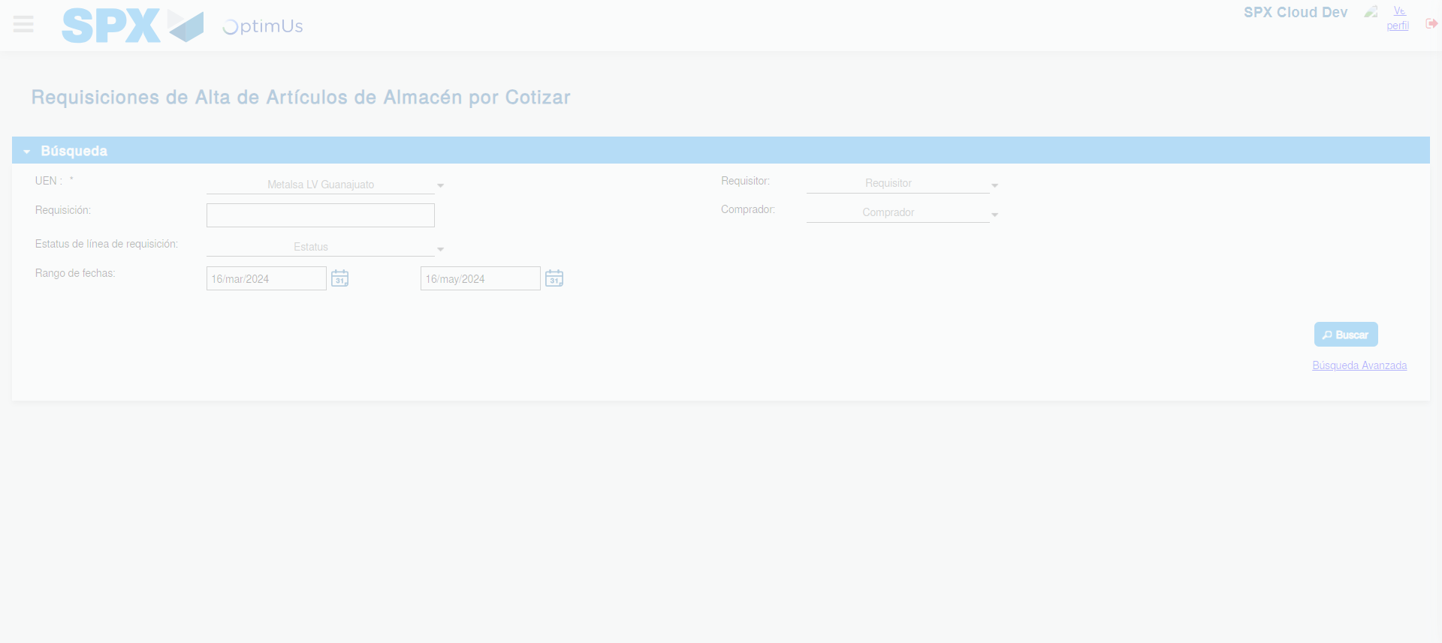Image file-name: QC_Testing-tc001_SPX_Dev5_Validar_Campos_Proceso_Nuevo_Articulos_Almacen-may. 16 2024, 06 53 46 p. m.

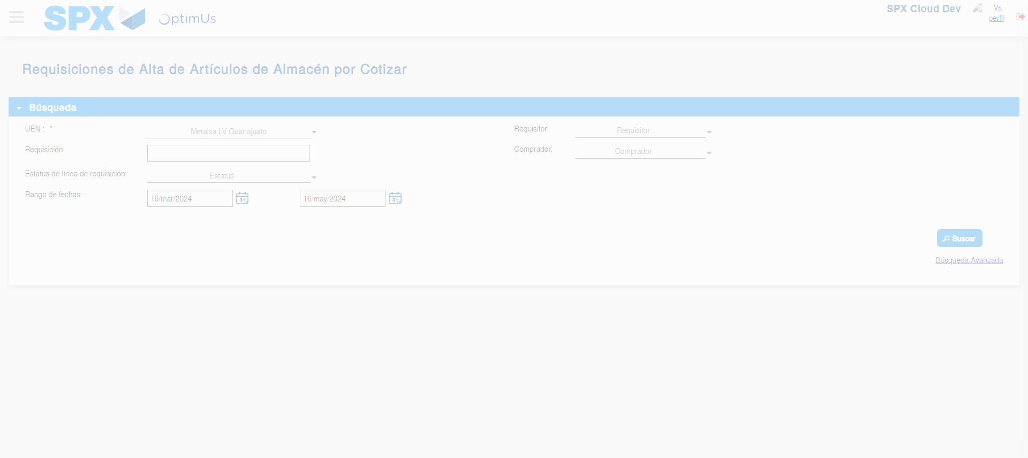Image file-name: QC_Testing-tc001_SPX_Dev5_Validar_Campos_Proceso_Nuevo_Articulos_Almacen-may. 16 2024, 06 53 49 p. m.

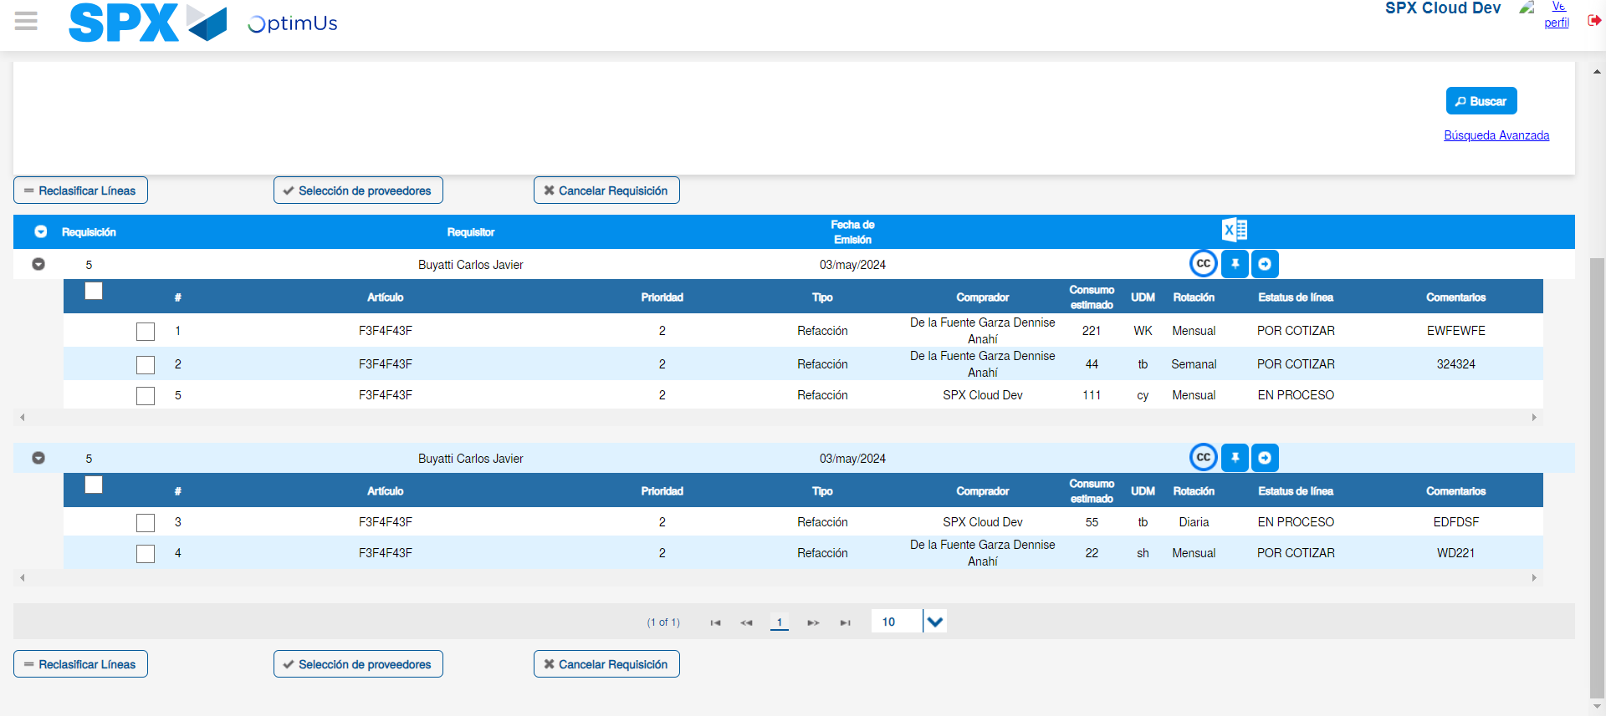Image file-name: QC_Testing-tc001_SPX_Dev5_Validar_Campos_Proceso_Nuevo_Articulos_Almacen-may. 16 2024, 06 53 53 p. m.

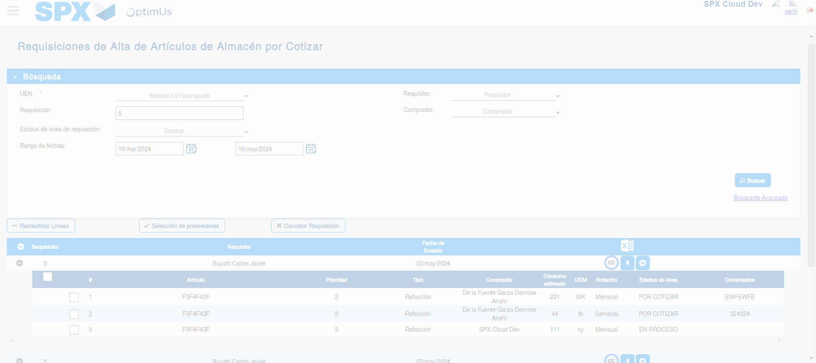Image file-name: QC_Testing-tc001_SPX_Dev5_Validar_Campos_Proceso_Nuevo_Articulos_Almacen-may. 16 2024, 06 53 54 p. m.

Image file-name: QC_Testing-tc001_SPX_Dev5_Validar_Campos_Proceso_Nuevo_Articulos_Almacen-may. 16 2024, 06 53 58 p. m.

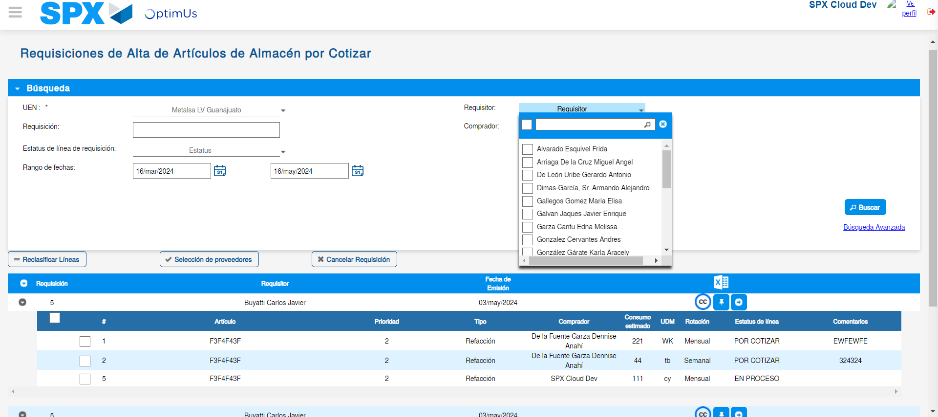Image file-name: QC_Testing-tc001_SPX_Dev5_Validar_Campos_Proceso_Nuevo_Articulos_Almacen-may. 16 2024, 06 53 59 p. m.

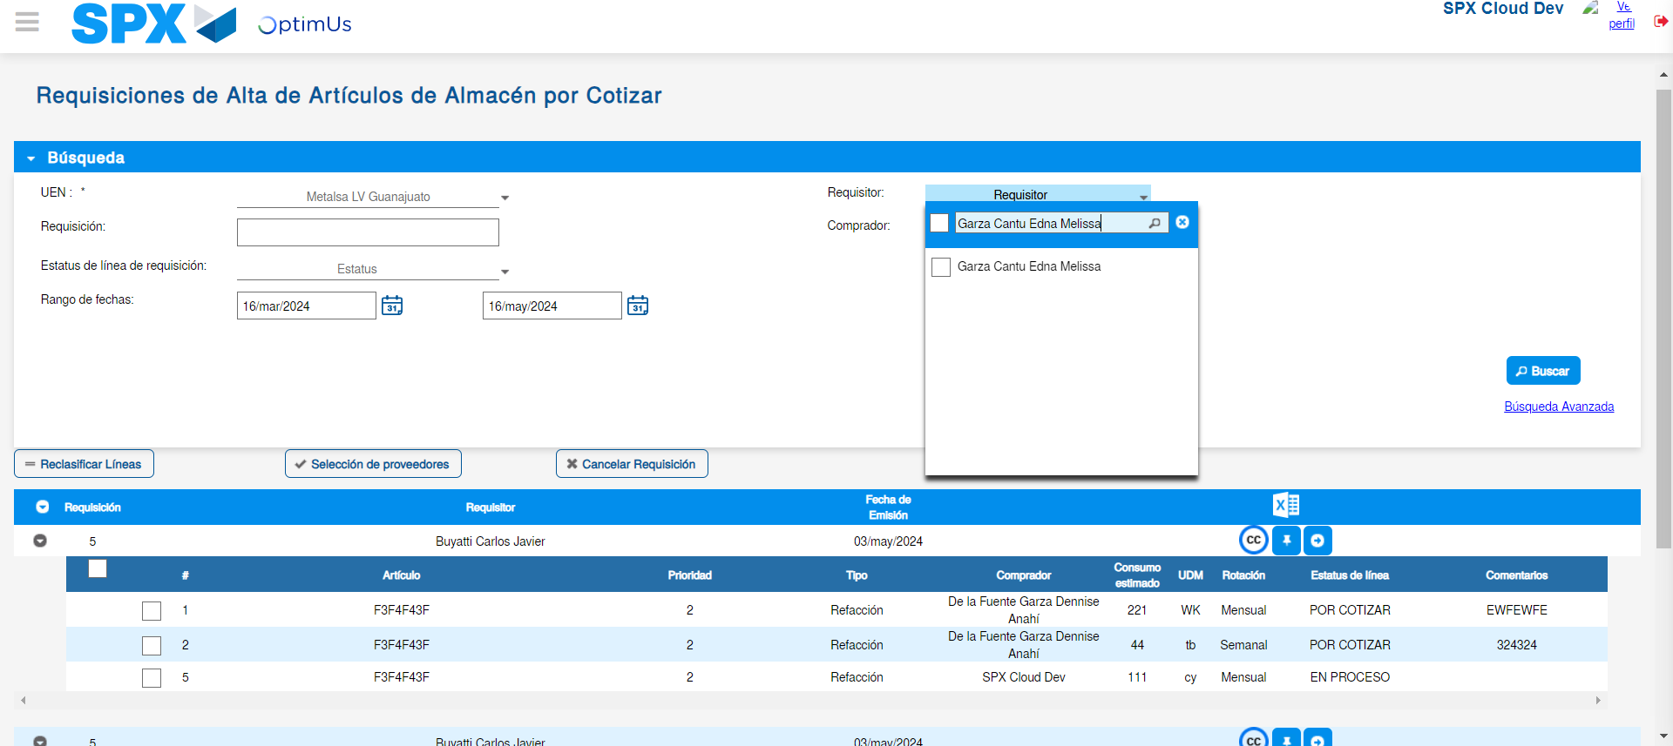Image file-name: QC_Testing-tc001_SPX_Dev5_Validar_Campos_Proceso_Nuevo_Articulos_Almacen-may. 16 2024, 06 54 00 p. m.

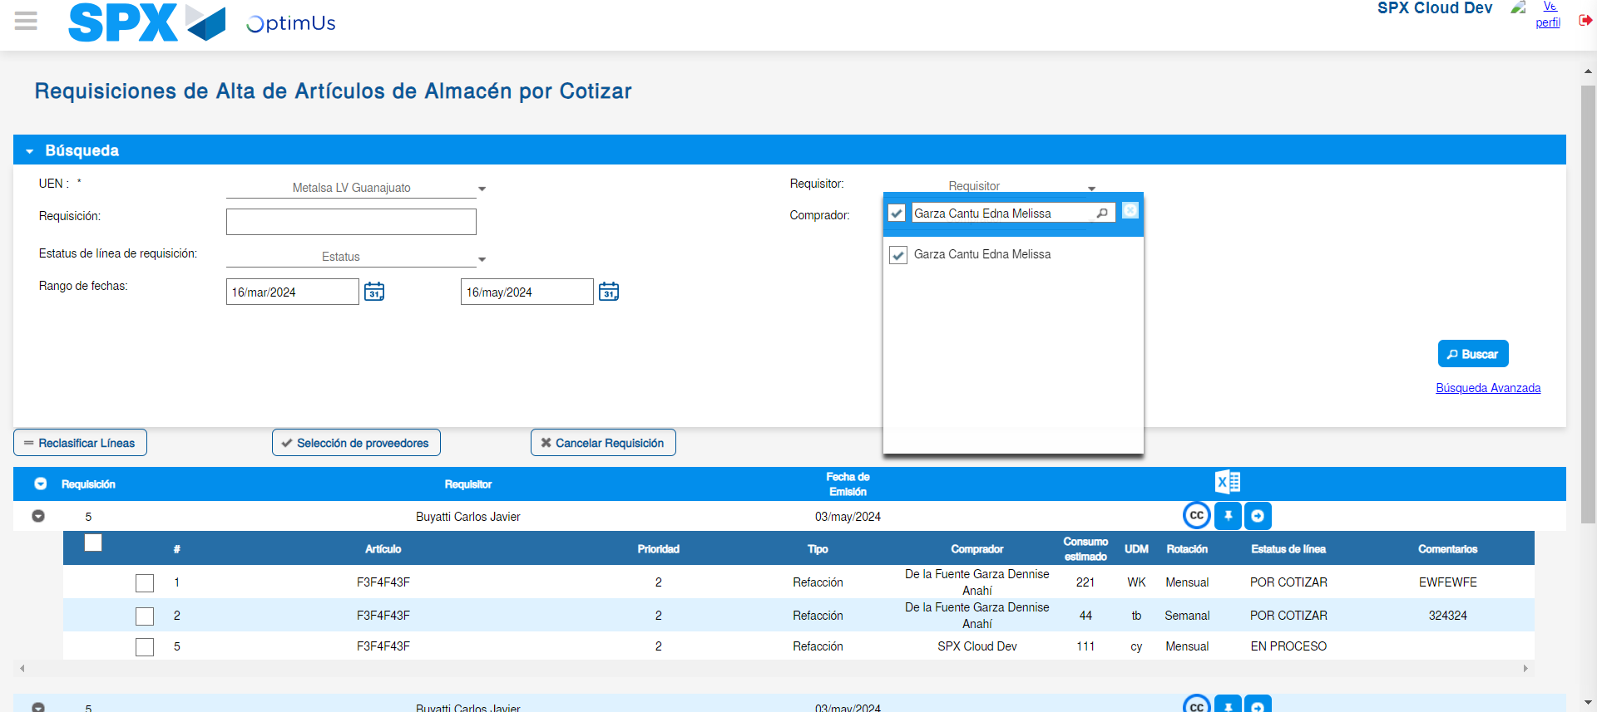Image file-name: QC_Testing-tc001_SPX_Dev5_Validar_Campos_Proceso_Nuevo_Articulos_Almacen-may. 16 2024, 06 54 01 p. m.

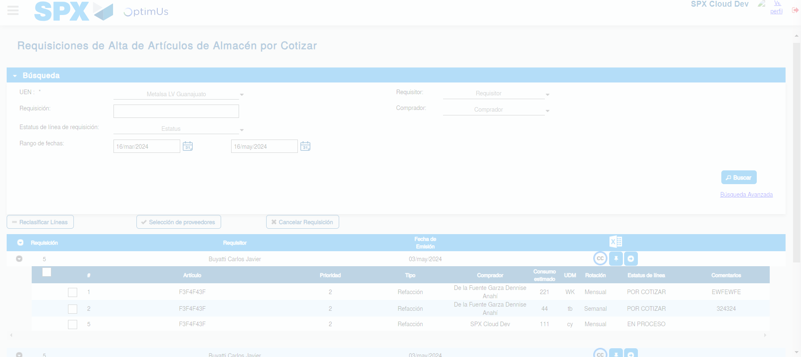Image file-name: QC_Testing-tc001_SPX_Dev5_Validar_Campos_Proceso_Nuevo_Articulos_Almacen-may. 16 2024, 06 54 05 p. m.

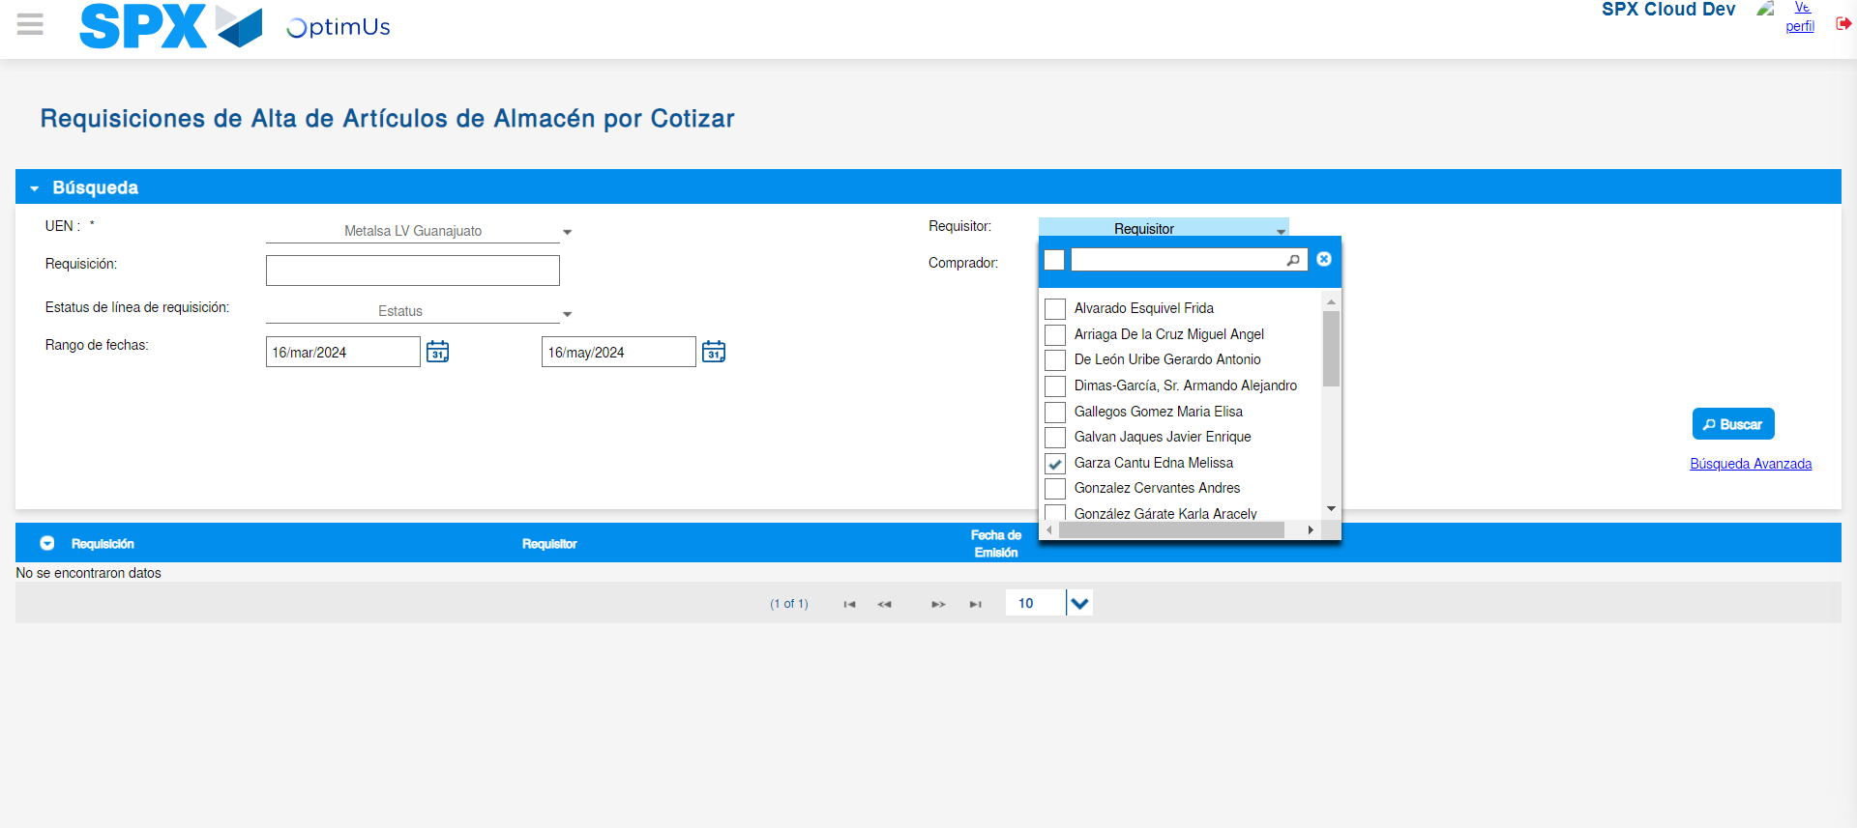Image file-name: QC_Testing-tc001_SPX_Dev5_Validar_Campos_Proceso_Nuevo_Articulos_Almacen-may. 16 2024, 06 54 09 p. m.

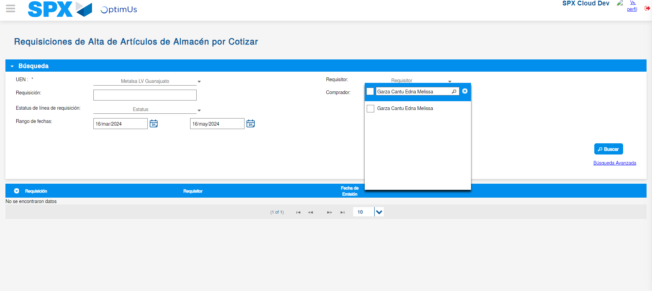Image file-name: QC_Testing-tc001_SPX_Dev5_Validar_Campos_Proceso_Nuevo_Articulos_Almacen-may. 16 2024, 06 54 10 p. m.

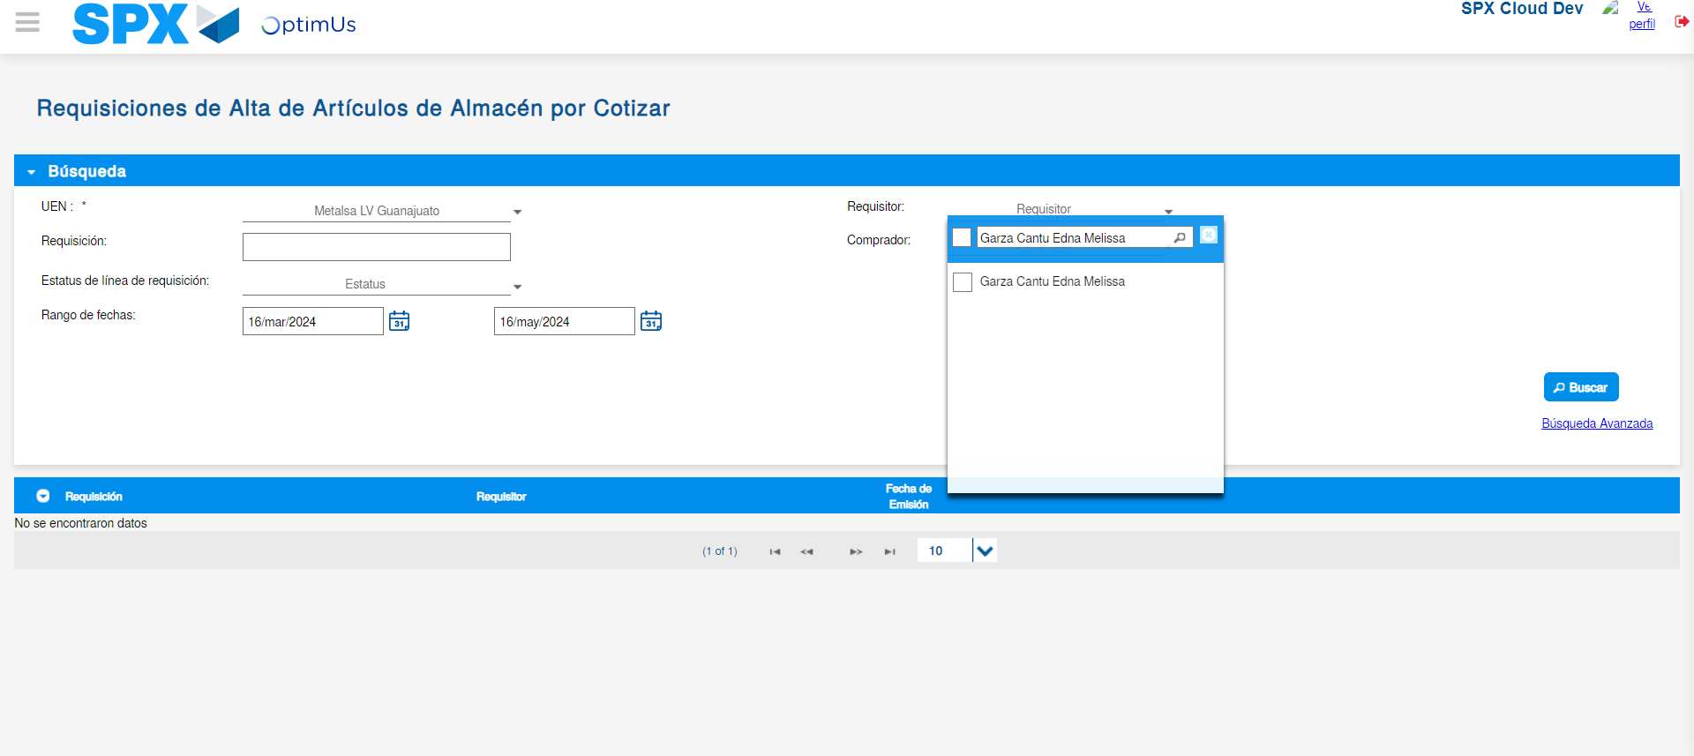Image file-name: QC_Testing-tc001_SPX_Dev5_Validar_Campos_Proceso_Nuevo_Articulos_Almacen-may. 16 2024, 06 54 11 p. m.

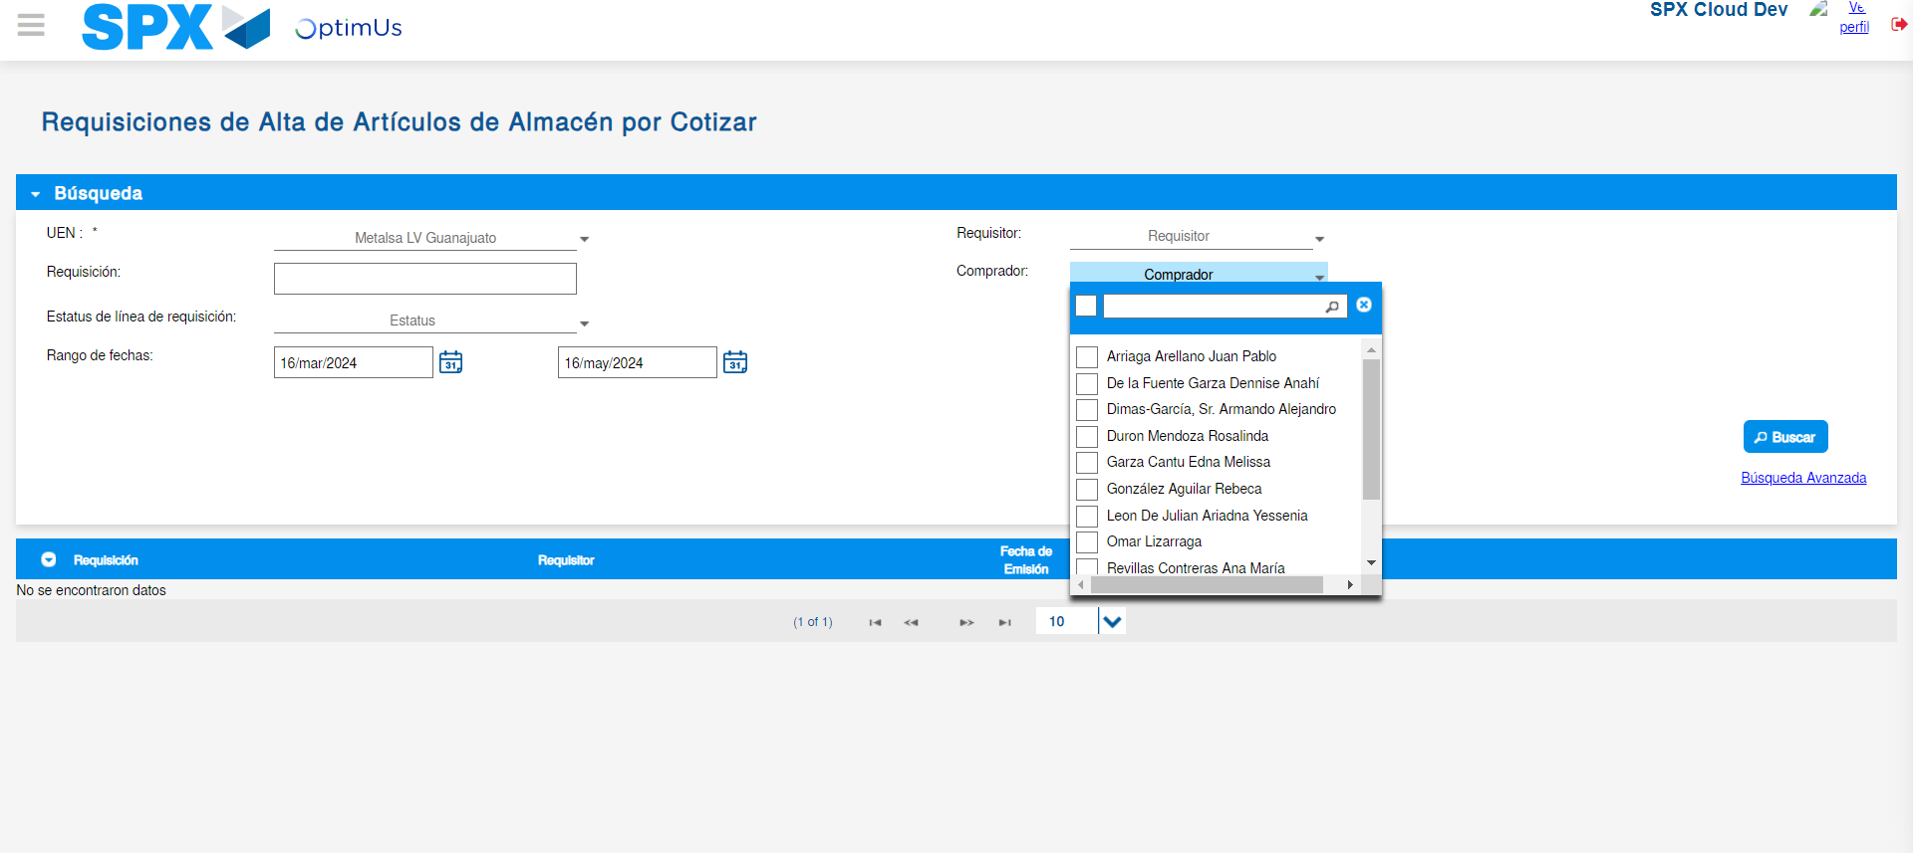Image file-name: QC_Testing-tc001_SPX_Dev5_Validar_Campos_Proceso_Nuevo_Articulos_Almacen-may. 16 2024, 06 54 14 p. m.

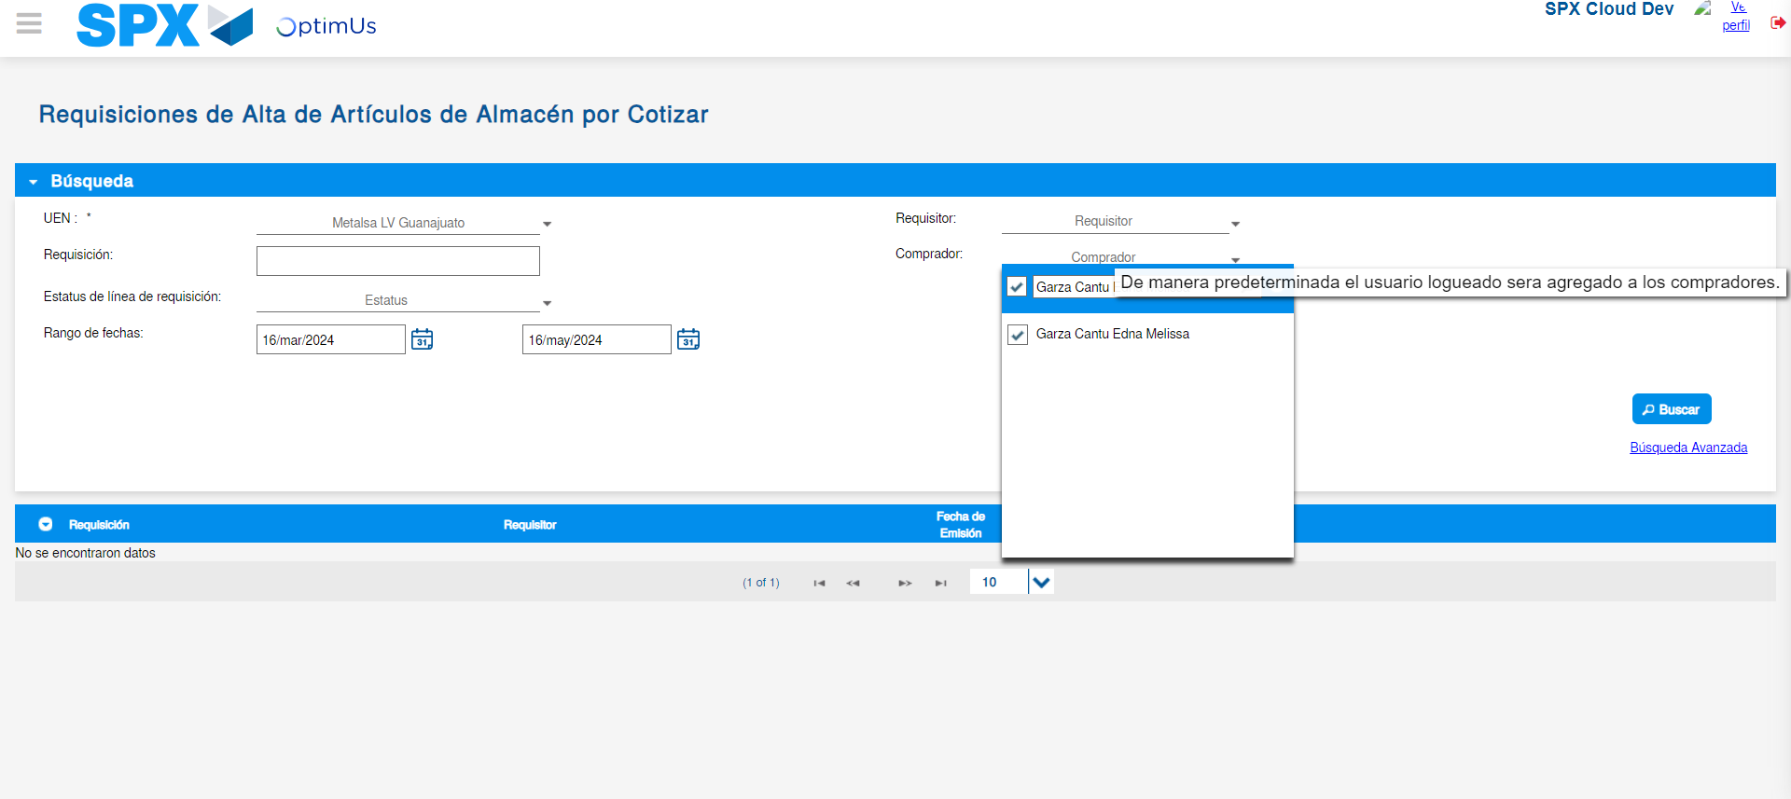Image file-name: QC_Testing-tc001_SPX_Dev5_Validar_Campos_Proceso_Nuevo_Articulos_Almacen-may. 16 2024, 06 54 15 p. m.

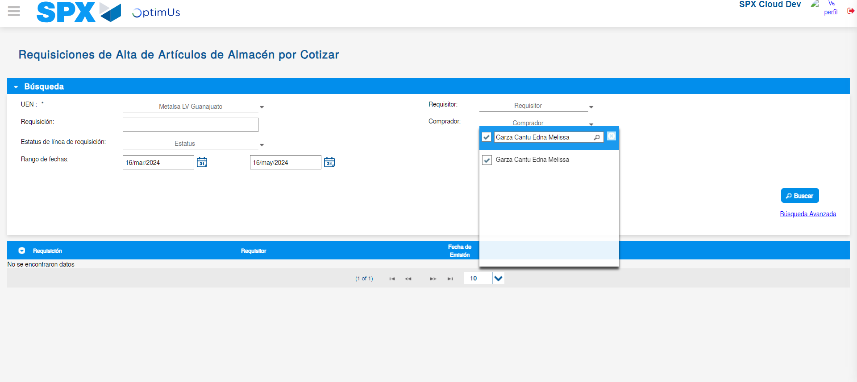Image file-name: QC_Testing-tc001_SPX_Dev5_Validar_Campos_Proceso_Nuevo_Articulos_Almacen-may. 16 2024, 06 54 16 p. m.

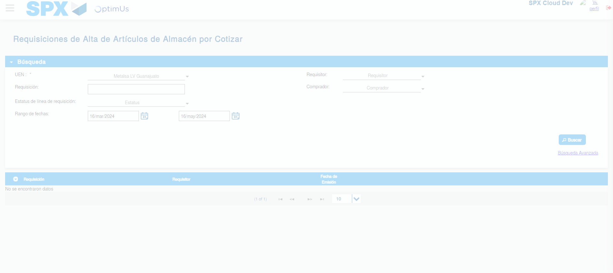Image file-name: QC_Testing-tc001_SPX_Dev5_Validar_Campos_Proceso_Nuevo_Articulos_Almacen-may. 16 2024, 06 54 20 p. m.

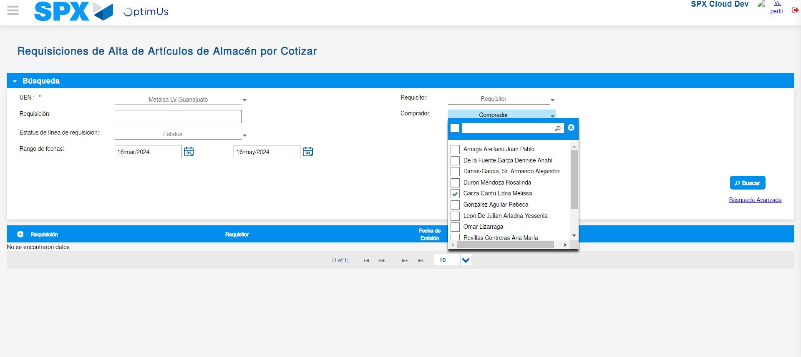Image file-name: QC_Testing-tc001_SPX_Dev5_Validar_Campos_Proceso_Nuevo_Articulos_Almacen-may. 16 2024, 06 54 23 p. m.

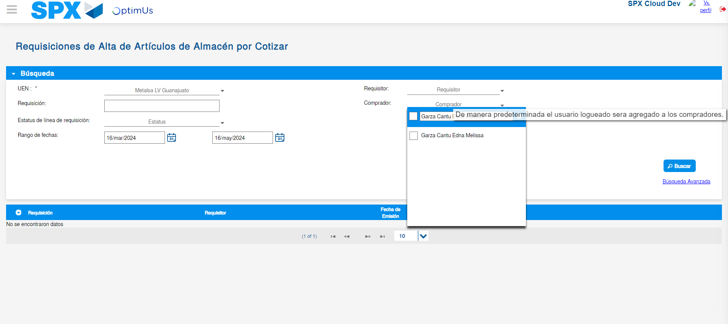Image file-name: QC_Testing-tc001_SPX_Dev5_Validar_Campos_Proceso_Nuevo_Articulos_Almacen-may. 16 2024, 06 54 24 p. m.

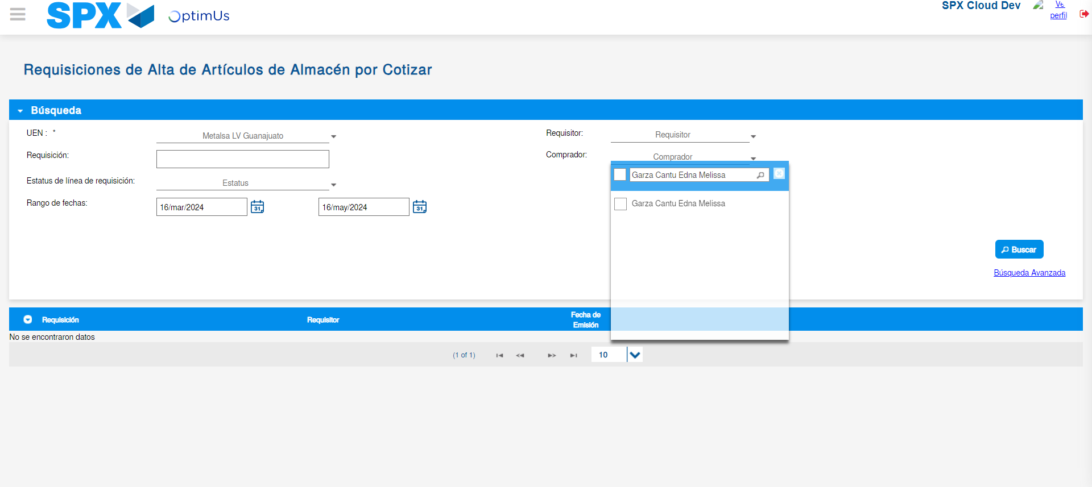Image file-name: QC_Testing-tc001_SPX_Dev5_Validar_Campos_Proceso_Nuevo_Articulos_Almacen-may. 16 2024, 06 54 25 p. m.

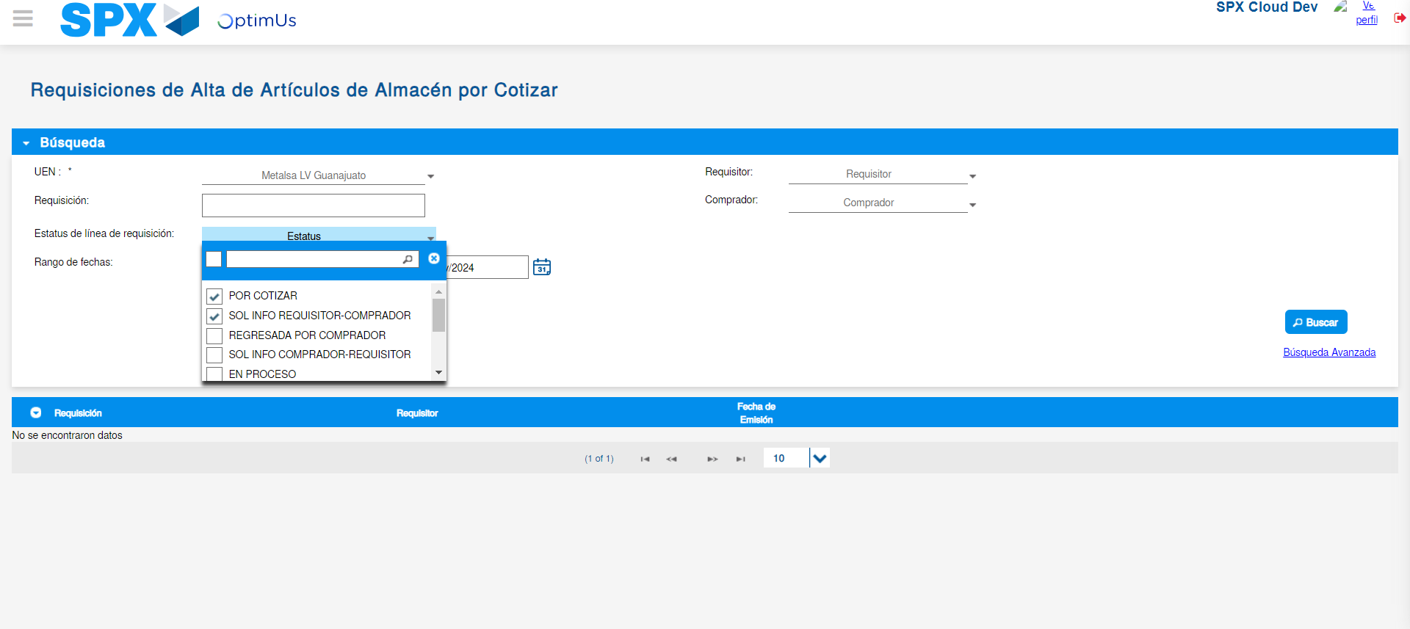Image file-name: QC_Testing-tc001_SPX_Dev5_Validar_Campos_Proceso_Nuevo_Articulos_Almacen-may. 16 2024, 06 54 29 p. m.

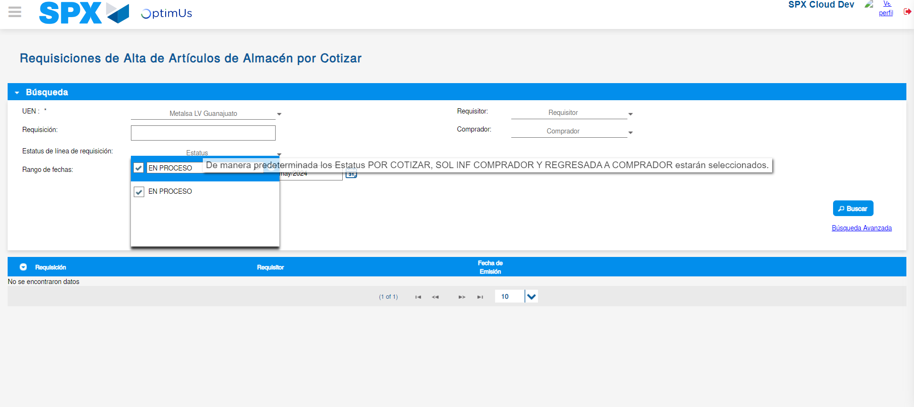Image file-name: QC_Testing-tc001_SPX_Dev5_Validar_Campos_Proceso_Nuevo_Articulos_Almacen-may. 16 2024, 06 54 30 p. m.

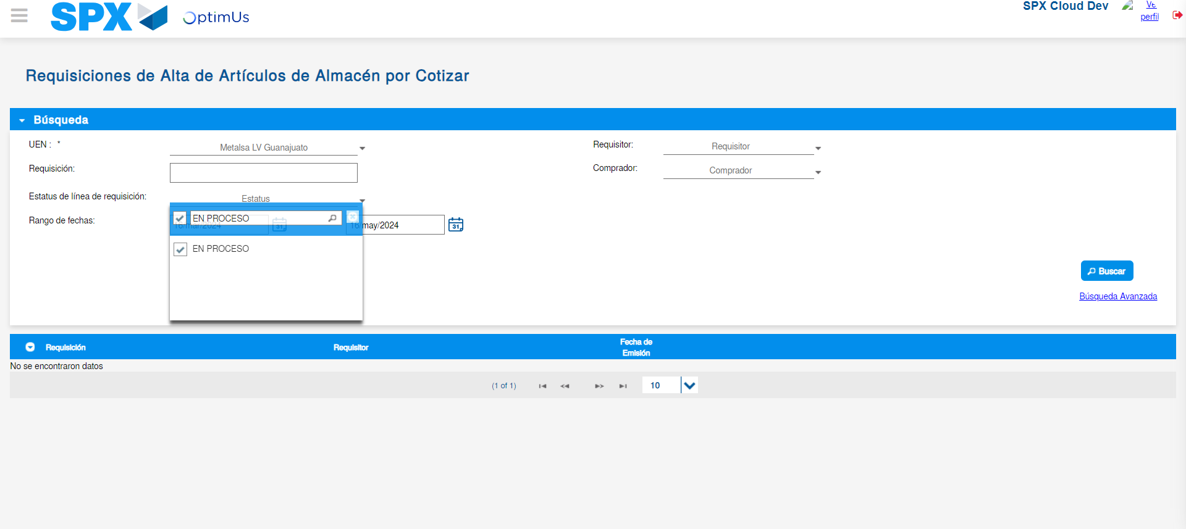Image file-name: QC_Testing-tc001_SPX_Dev5_Validar_Campos_Proceso_Nuevo_Articulos_Almacen-may. 16 2024, 06 54 31 p. m.

Image file-name: QC_Testing-tc001_SPX_Dev5_Validar_Campos_Proceso_Nuevo_Articulos_Almacen-may. 16 2024, 06 54 35 p. m.

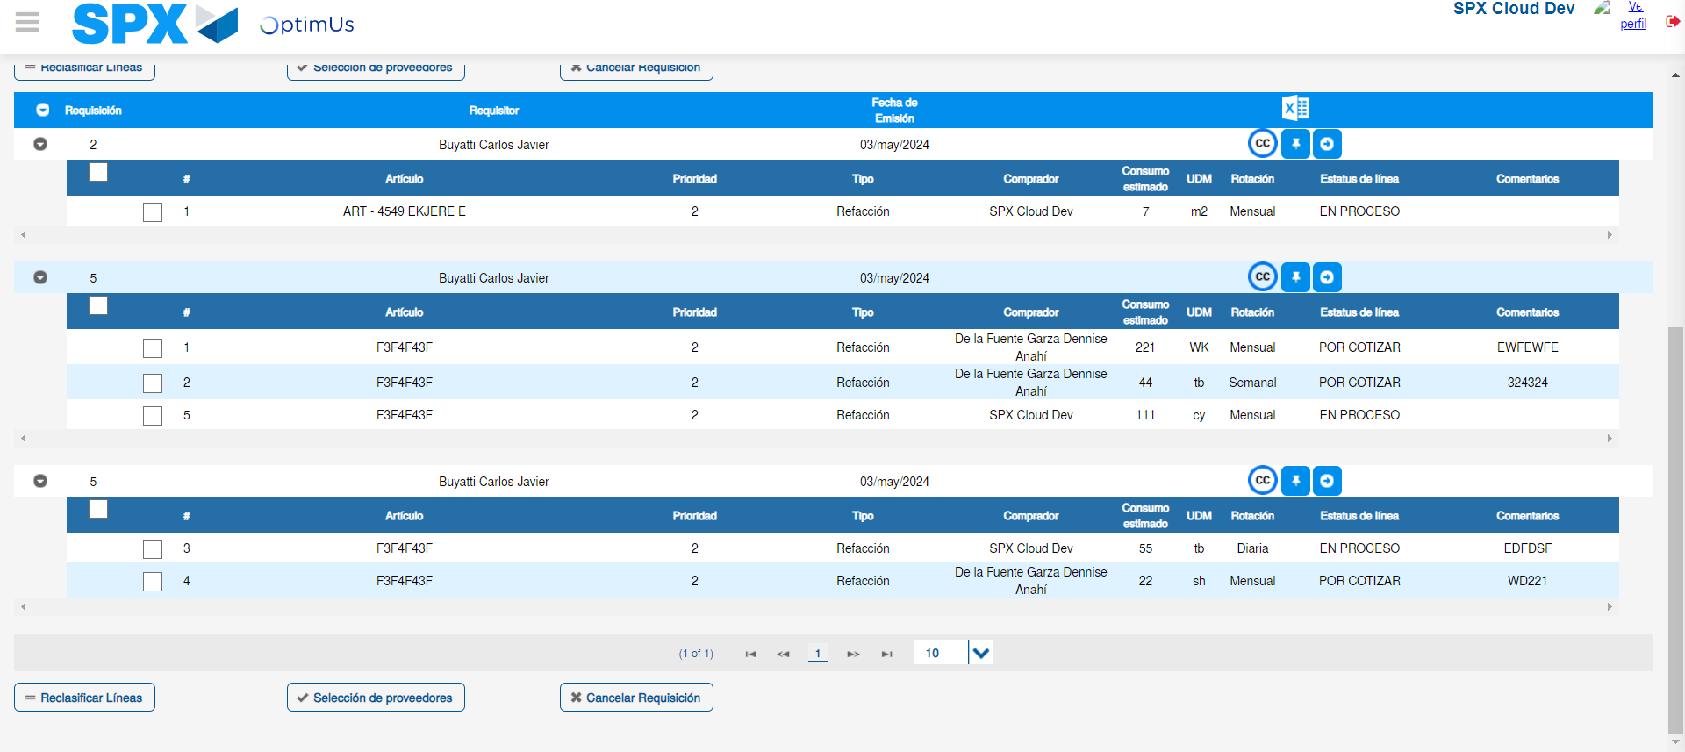Image file-name: QC_Testing-tc001_SPX_Dev5_Validar_Campos_Proceso_Nuevo_Articulos_Almacen-may. 16 2024, 06 54 38 p. m.

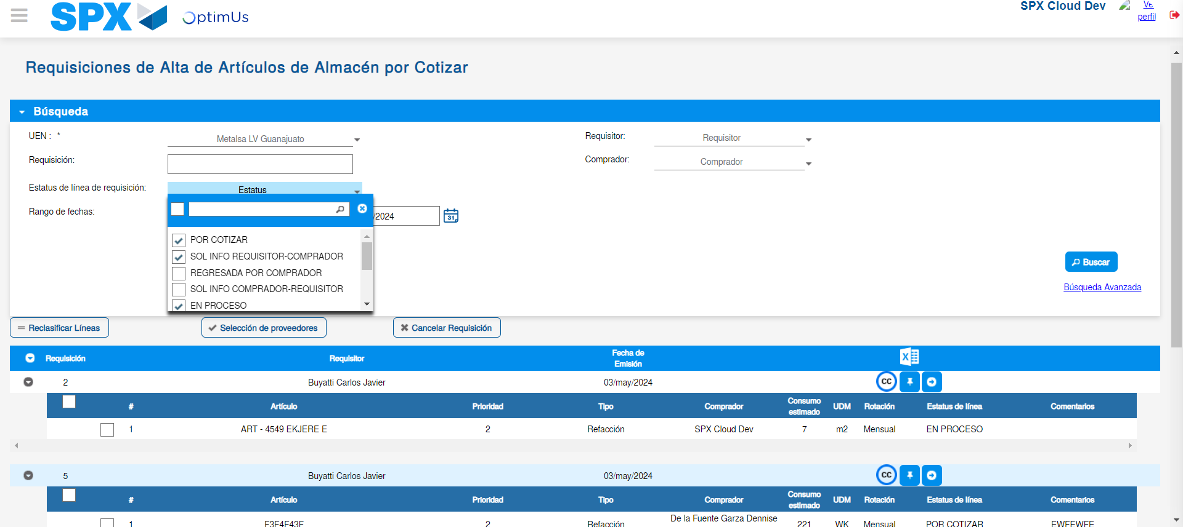Image file-name: QC_Testing-tc001_SPX_Dev5_Validar_Campos_Proceso_Nuevo_Articulos_Almacen-may. 16 2024, 06 54 39 p. m.

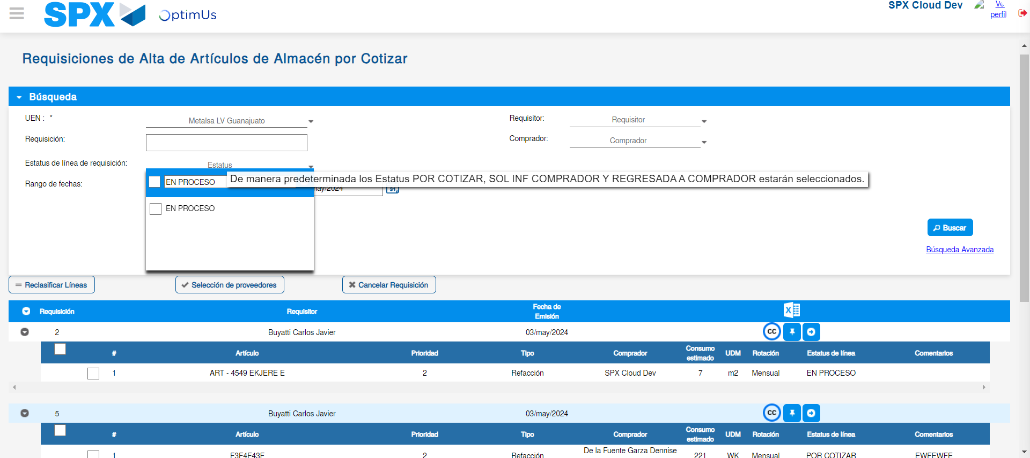Image file-name: QC_Testing-tc001_SPX_Dev5_Validar_Campos_Proceso_Nuevo_Articulos_Almacen-may. 16 2024, 06 54 40 p. m.

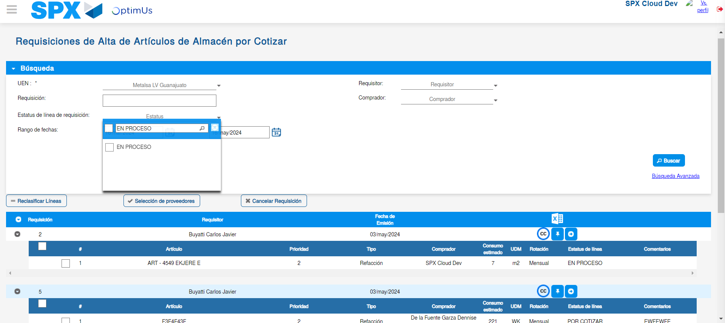Image file-name: QC_Testing-tc001_SPX_Dev5_Validar_Campos_Proceso_Nuevo_Articulos_Almacen-may. 16 2024, 06 54 41 p. m.

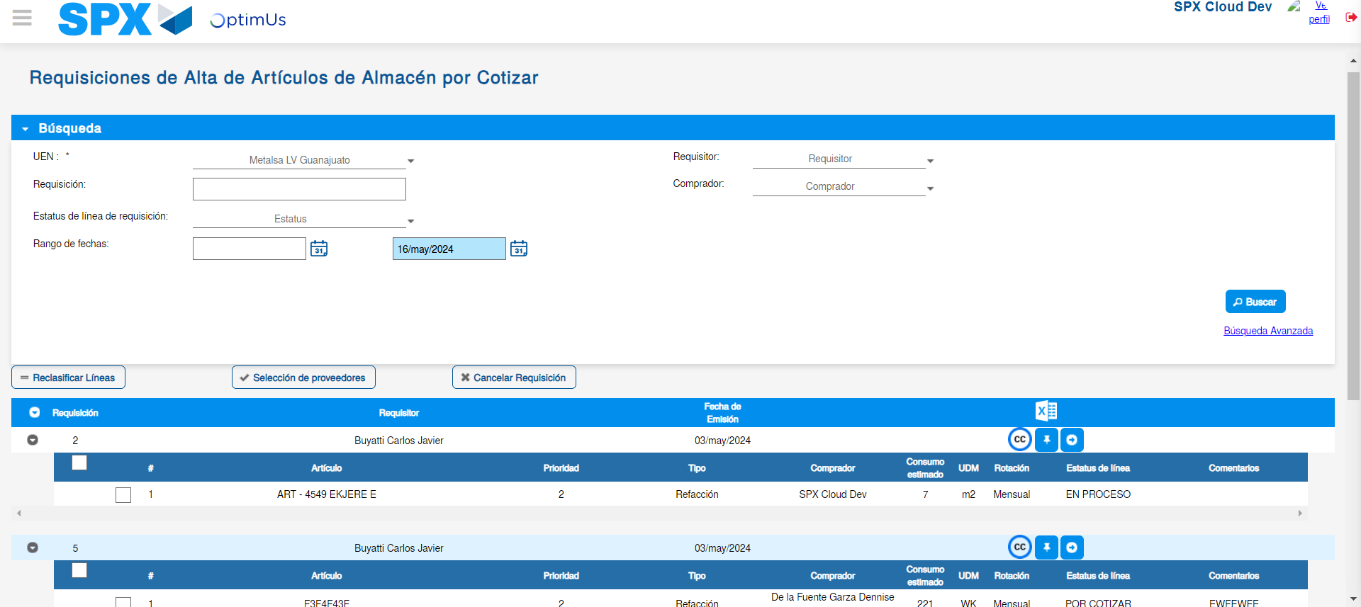Image file-name: QC_Testing-tc001_SPX_Dev5_Validar_Campos_Proceso_Nuevo_Articulos_Almacen-may. 16 2024, 06 54 44 p. m.

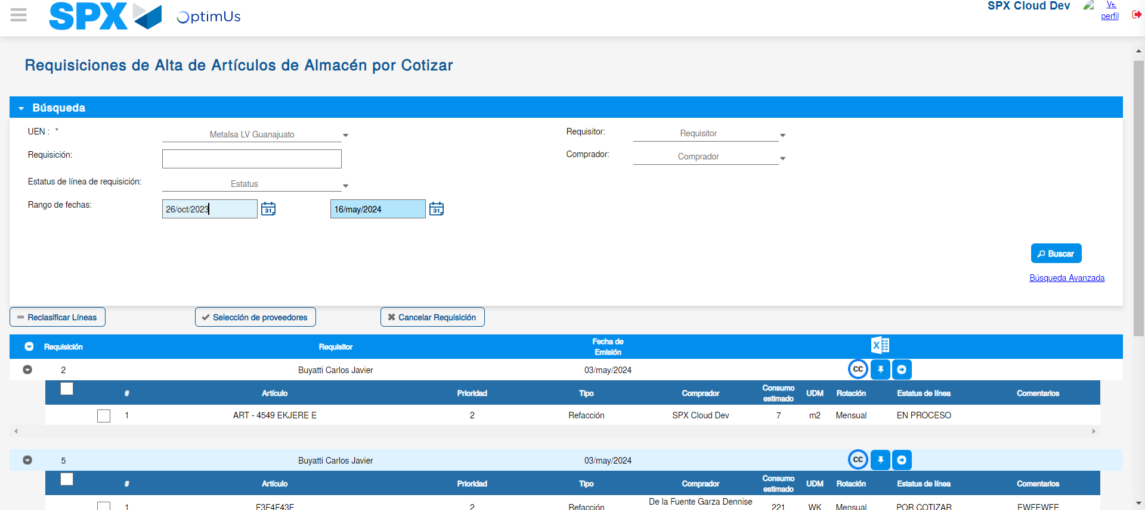Image file-name: QC_Testing-tc001_SPX_Dev5_Validar_Campos_Proceso_Nuevo_Articulos_Almacen-may. 16 2024, 06 54 45 p. m.

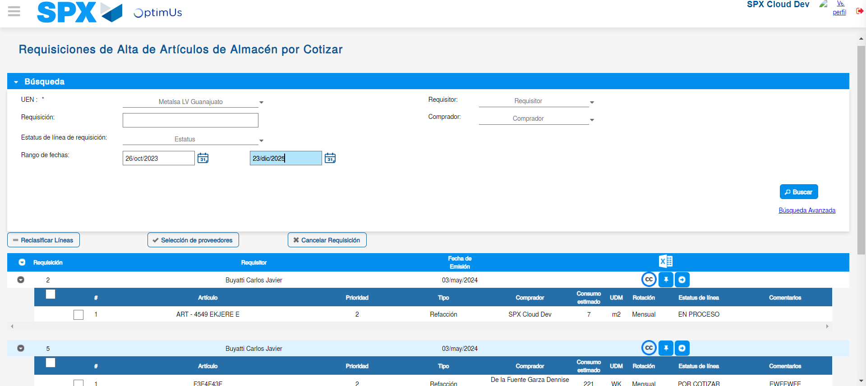Image file-name: QC_Testing-tc001_SPX_Dev5_Validar_Campos_Proceso_Nuevo_Articulos_Almacen-may. 16 2024, 06 54 49 p. m.

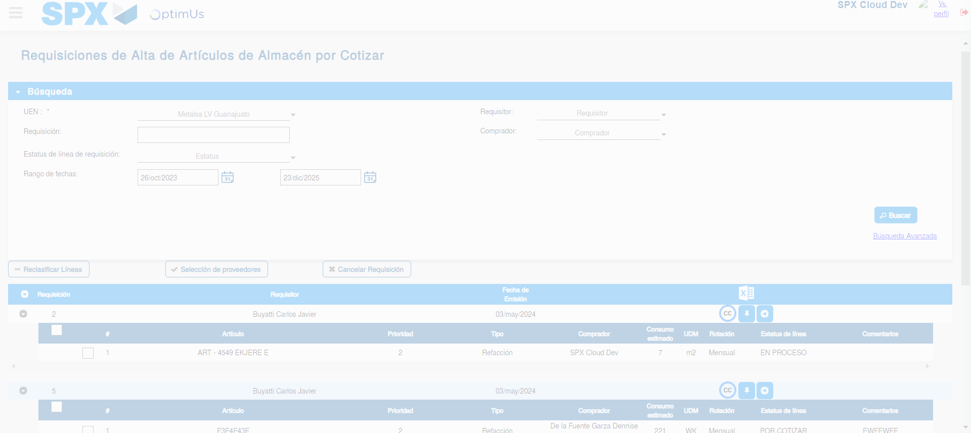Image file-name: QC_Testing-tc001_SPX_Dev5_Validar_Campos_Proceso_Nuevo_Articulos_Almacen-may. 16 2024, 06 54 53 p. m.

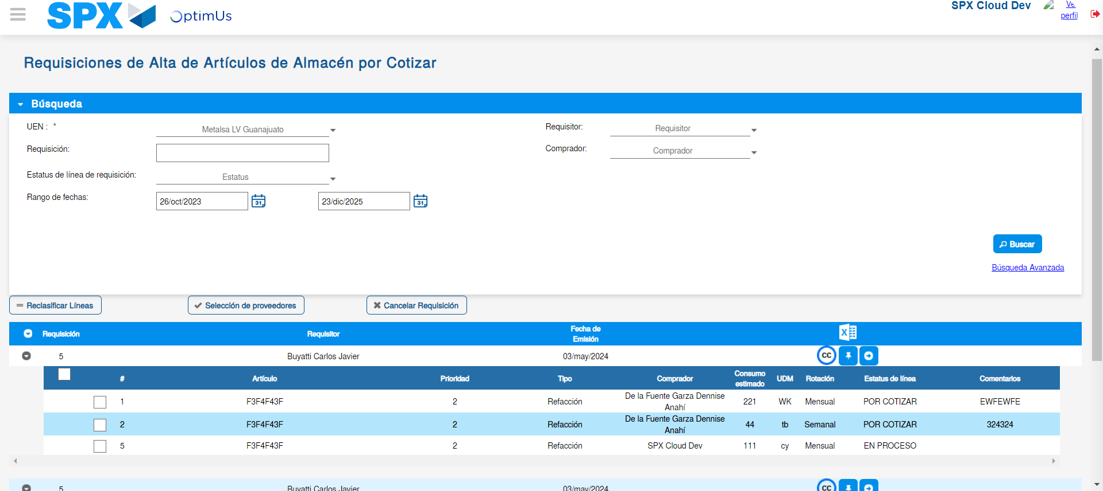Image file-name: QC_Testing-tc001_SPX_Dev5_Validar_Campos_Proceso_Nuevo_Articulos_Almacen-may. 16 2024, 06 54 57 p. m.

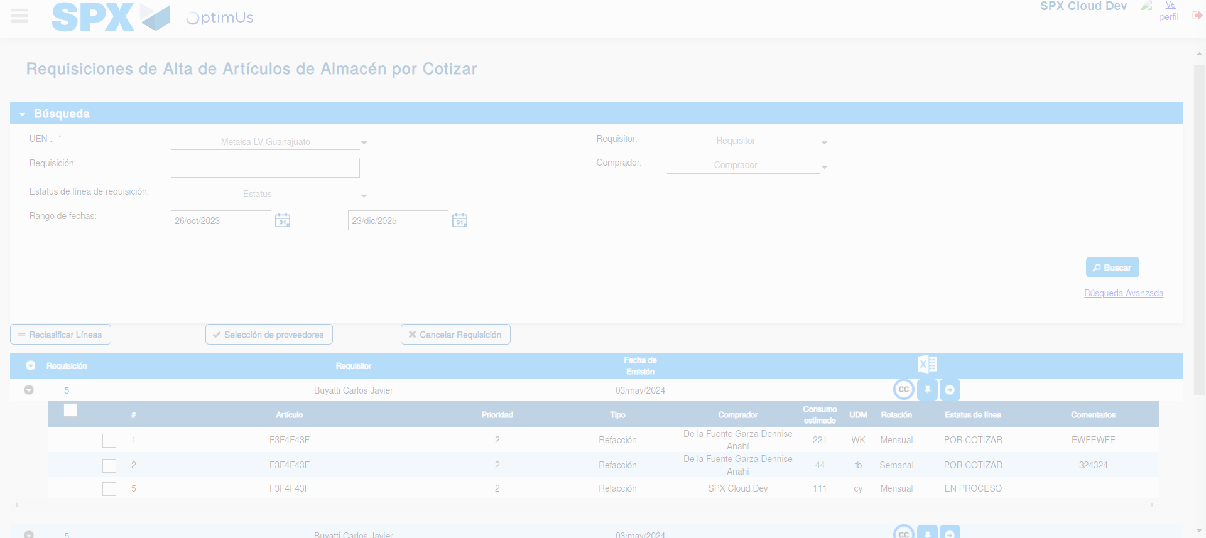Image file-name: QC_Testing-tc001_SPX_Dev5_Validar_Campos_Proceso_Nuevo_Articulos_Almacen-may. 16 2024, 06 54 58 p. m.

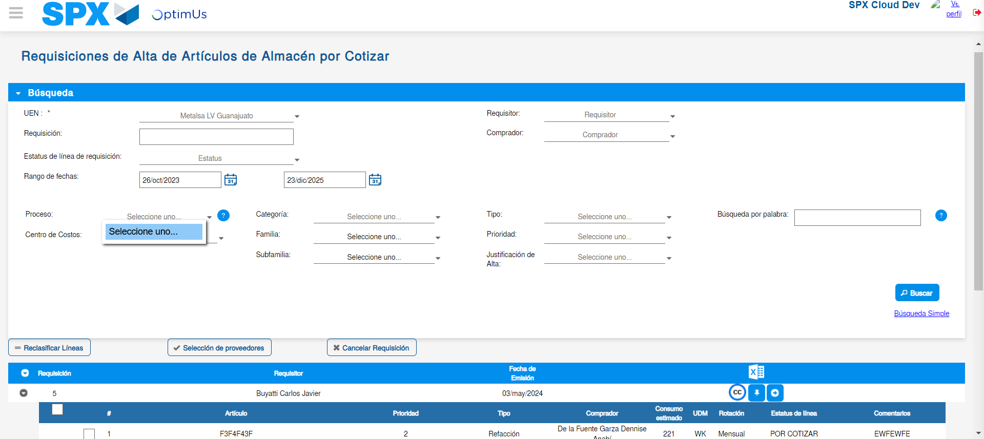Image file-name: QC_Testing-tc001_SPX_Dev5_Validar_Campos_Proceso_Nuevo_Articulos_Almacen-may. 16 2024, 06 54 59 p. m.

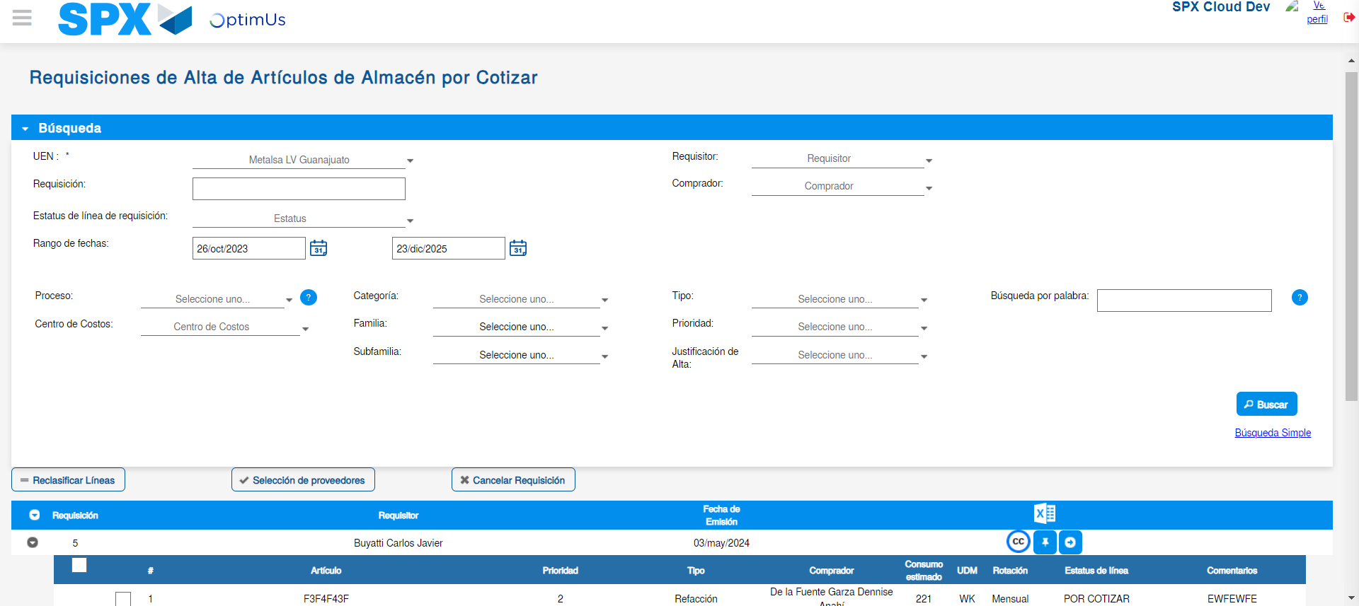Image file-name: QC_Testing-tc001_SPX_Dev5_Validar_Campos_Proceso_Nuevo_Articulos_Almacen-may. 16 2024, 06 55 00 p. m.

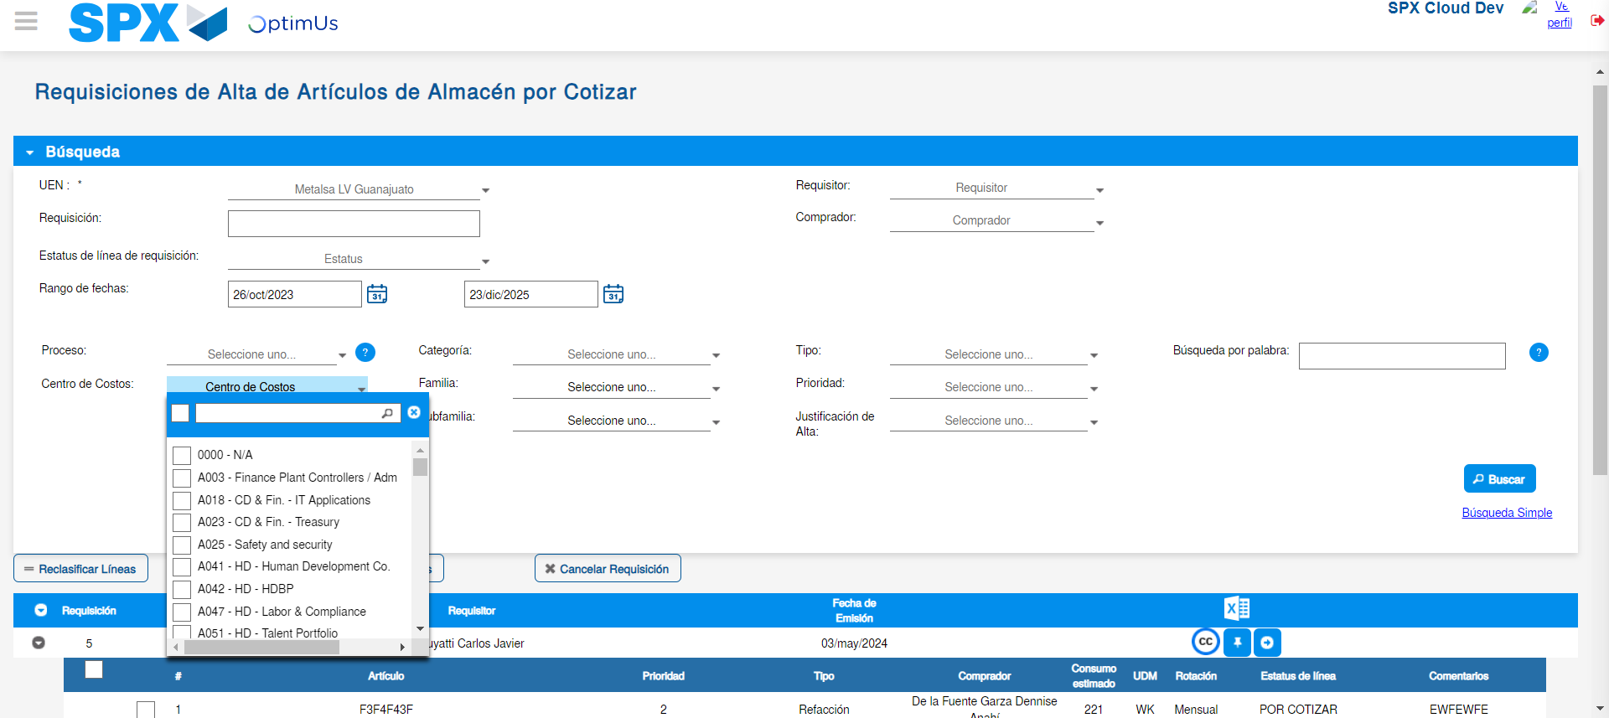Image file-name: QC_Testing-tc001_SPX_Dev5_Validar_Campos_Proceso_Nuevo_Articulos_Almacen-may. 16 2024, 06 55 01 p. m.

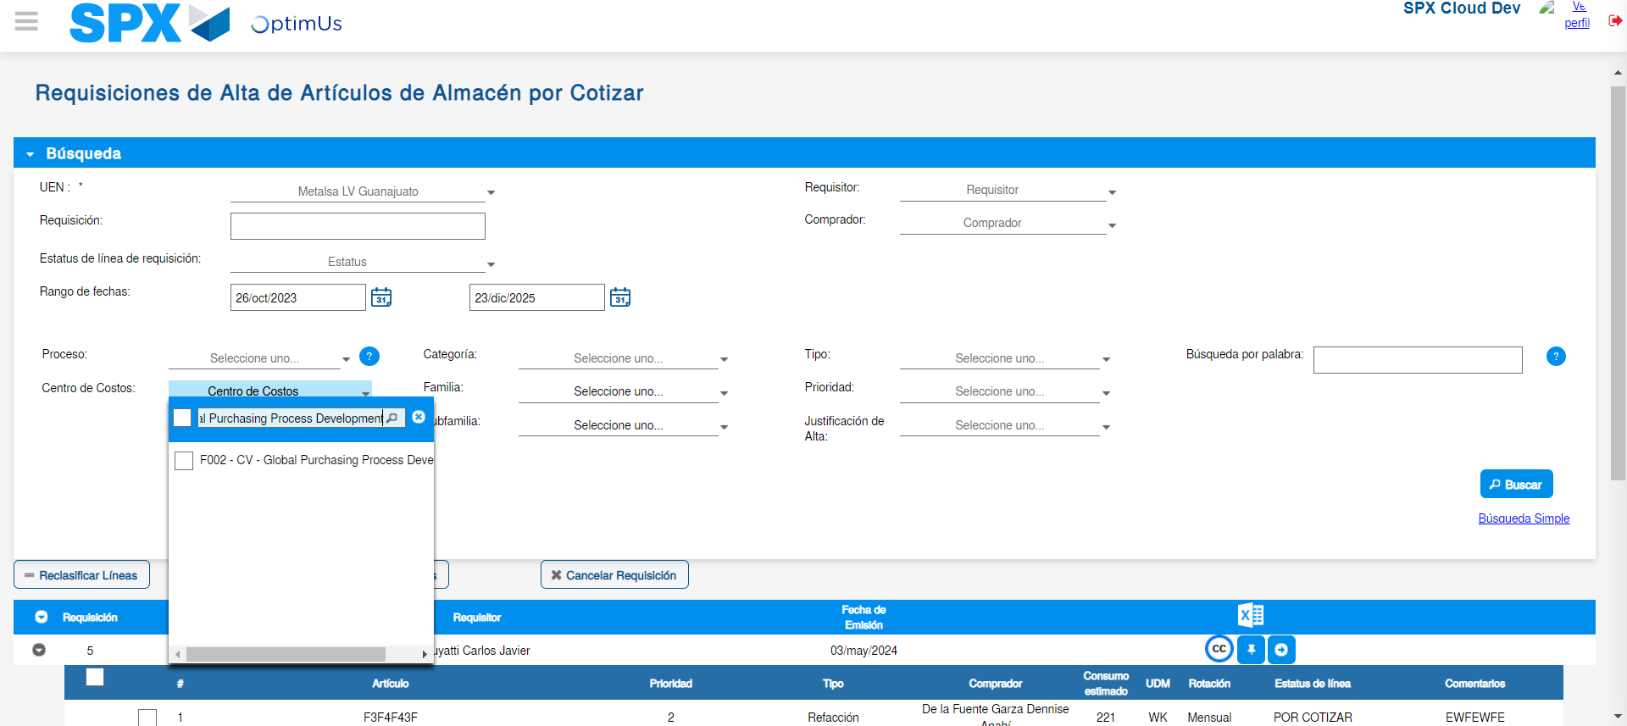Image file-name: QC_Testing-tc001_SPX_Dev5_Validar_Campos_Proceso_Nuevo_Articulos_Almacen-may. 16 2024, 06 55 04 p. m.

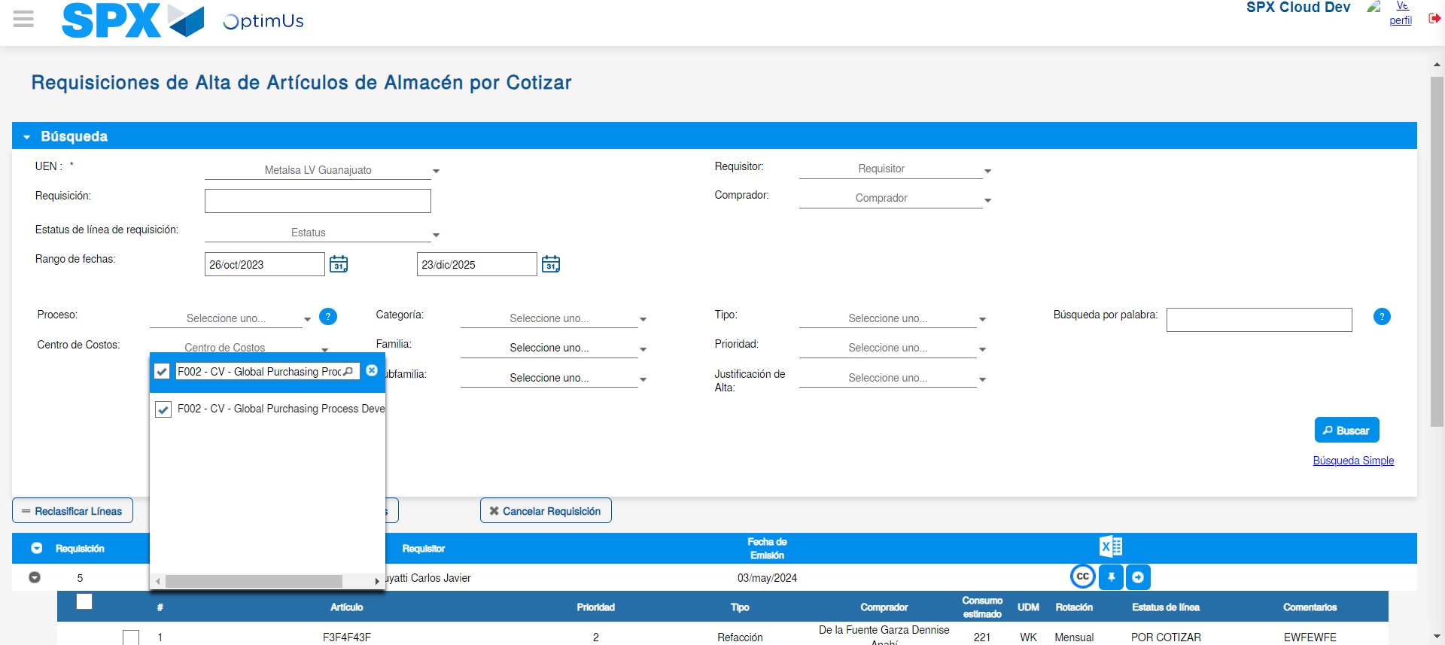Image file-name: QC_Testing-tc001_SPX_Dev5_Validar_Campos_Proceso_Nuevo_Articulos_Almacen-may. 16 2024, 06 55 07 p. m.

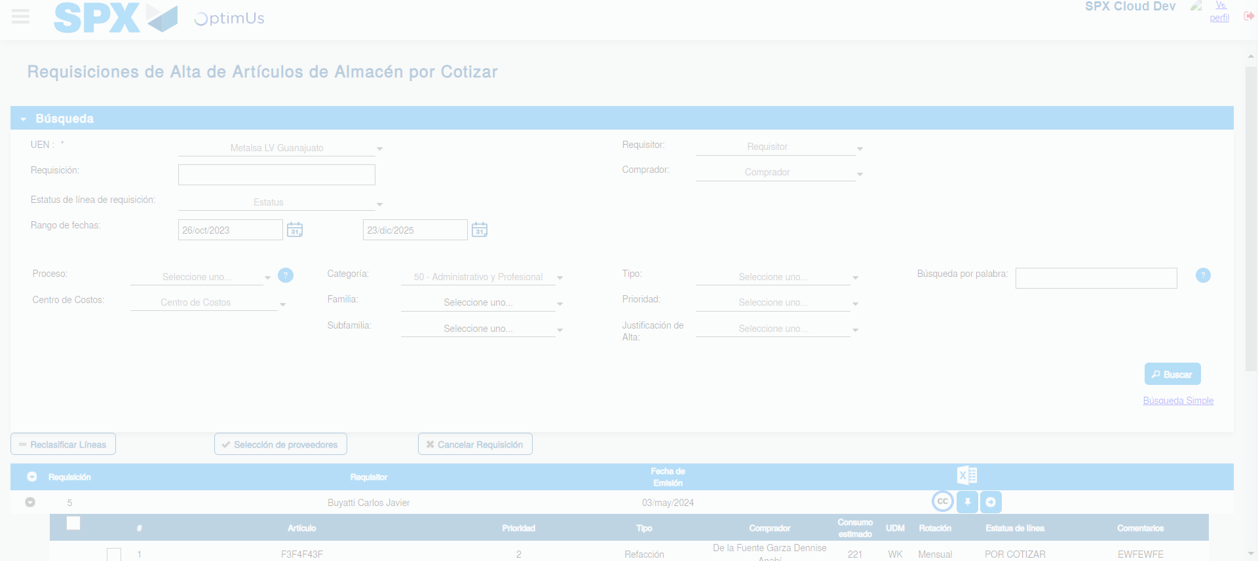Image file-name: QC_Testing-tc001_SPX_Dev5_Validar_Campos_Proceso_Nuevo_Articulos_Almacen-may. 16 2024, 06 55 11 p. m.

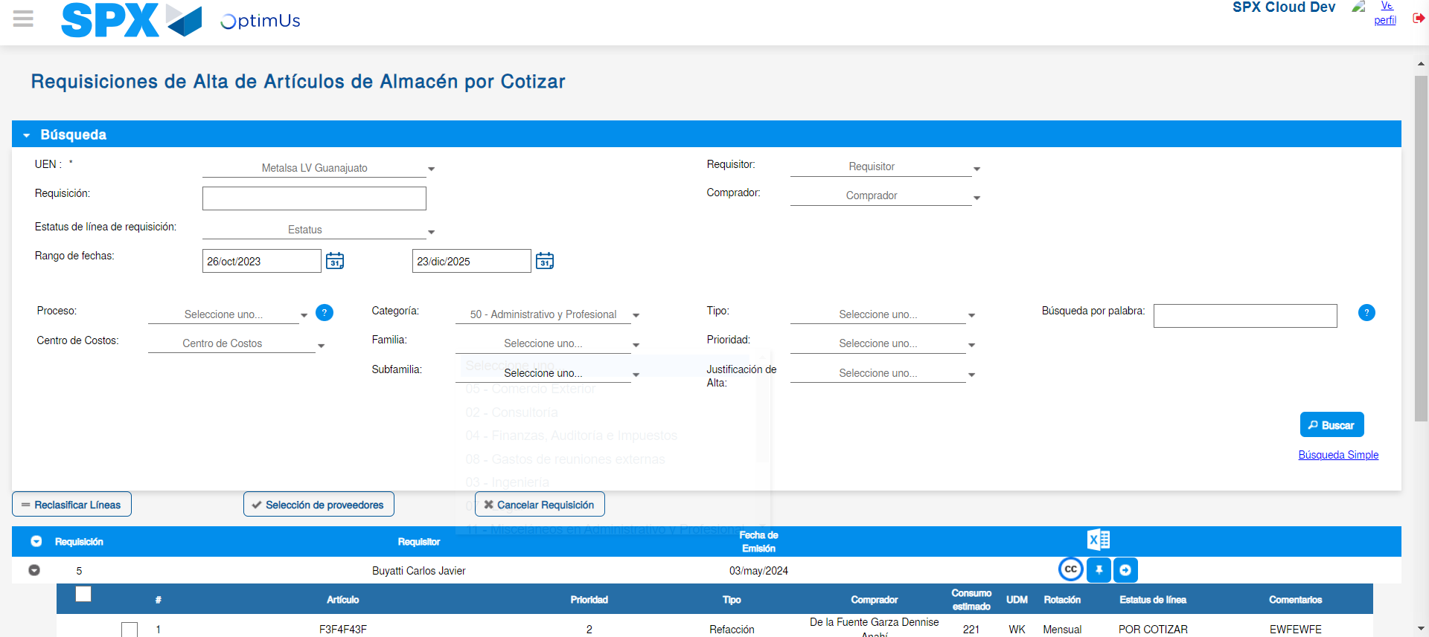Image file-name: QC_Testing-tc001_SPX_Dev5_Validar_Campos_Proceso_Nuevo_Articulos_Almacen-may. 16 2024, 06 55 15 p. m.

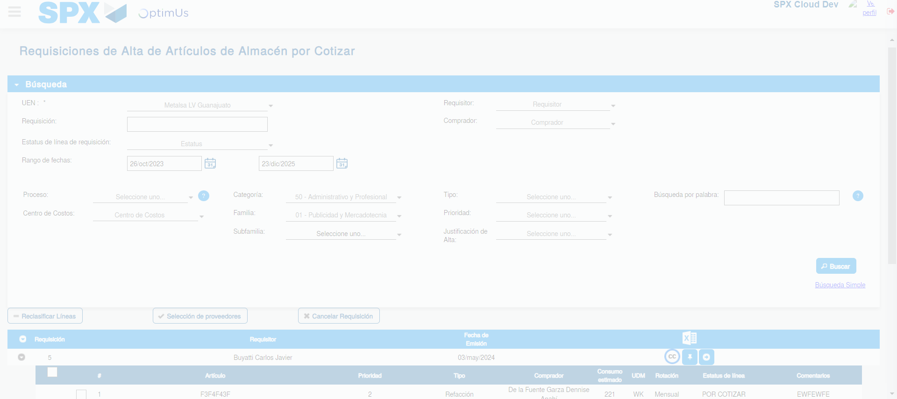Image file-name: QC_Testing-tc001_SPX_Dev5_Validar_Campos_Proceso_Nuevo_Articulos_Almacen-may. 16 2024, 06 55 16 p. m.

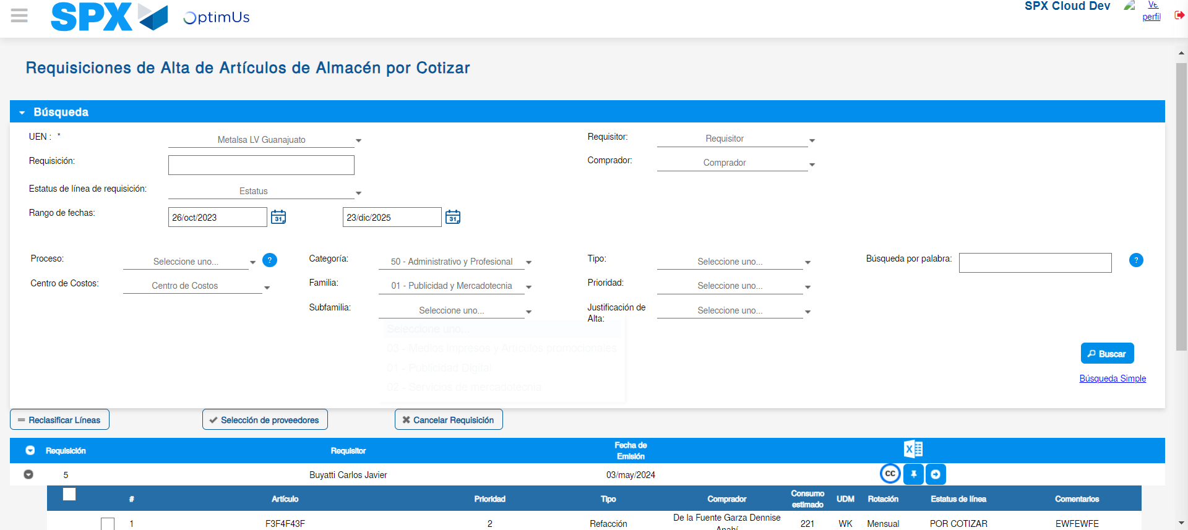Image file-name: QC_Testing-tc001_SPX_Dev5_Validar_Campos_Proceso_Nuevo_Articulos_Almacen-may. 16 2024, 06 55 19 p. m.

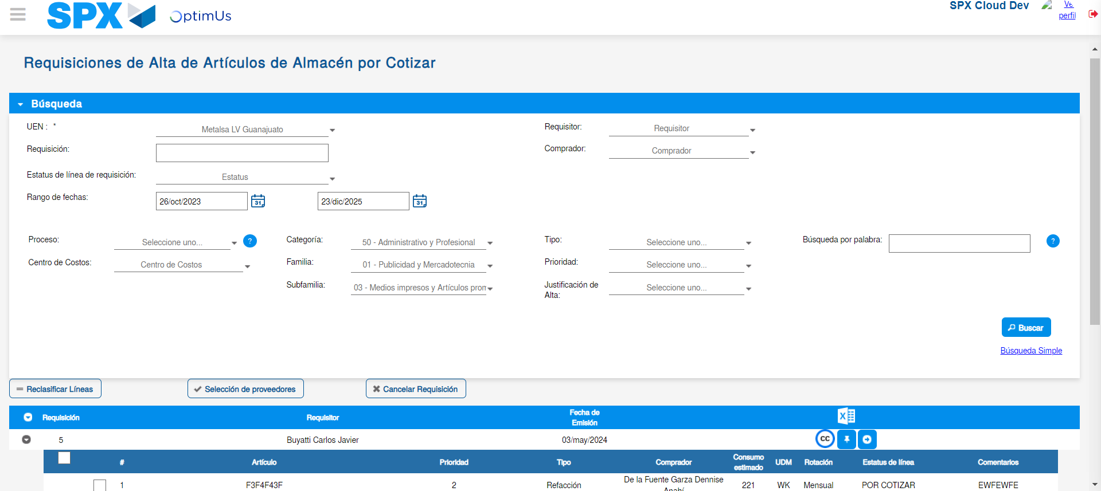Image file-name: QC_Testing-tc001_SPX_Dev5_Validar_Campos_Proceso_Nuevo_Articulos_Almacen-may. 16 2024, 06 55 20 p. m.

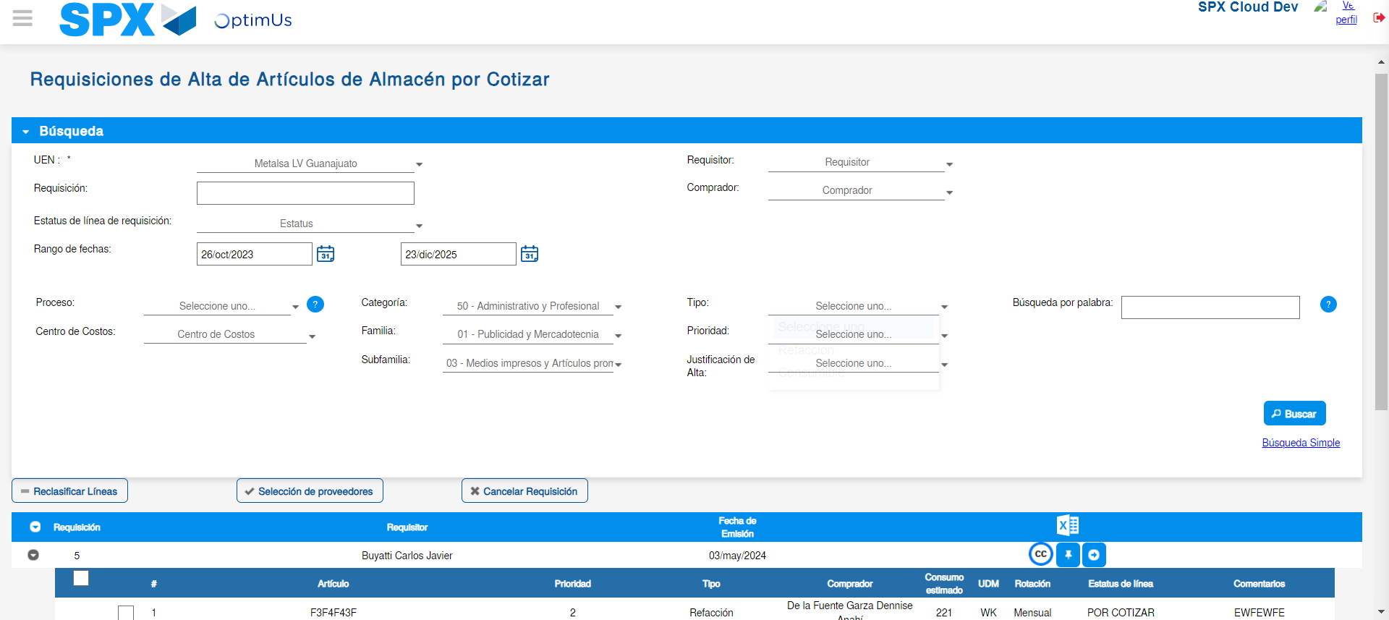Image file-name: QC_Testing-tc001_SPX_Dev5_Validar_Campos_Proceso_Nuevo_Articulos_Almacen-may. 16 2024, 06 55 23 p. m.

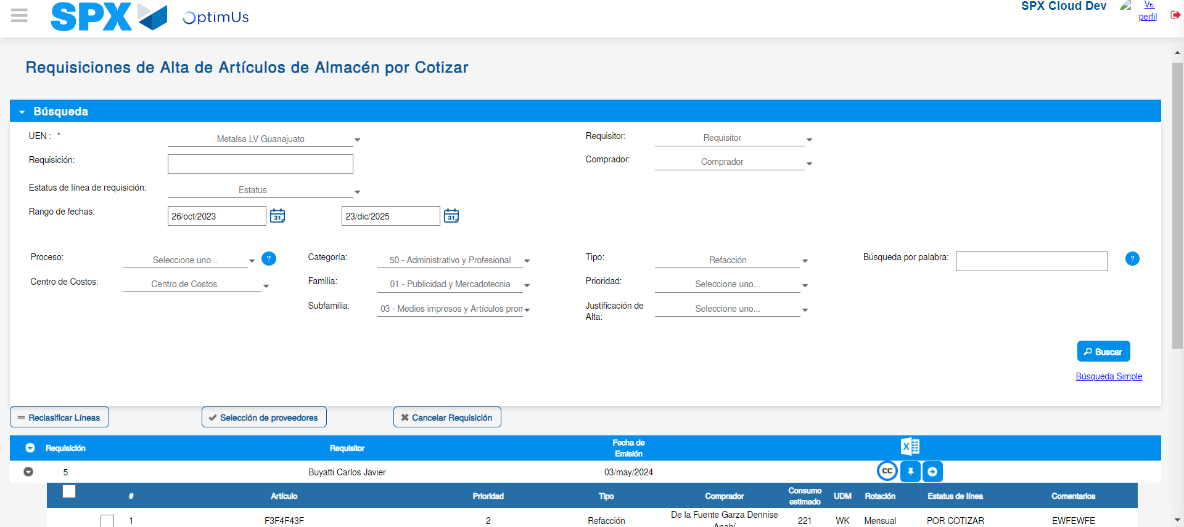Image file-name: QC_Testing-tc001_SPX_Dev5_Validar_Campos_Proceso_Nuevo_Articulos_Almacen-may. 16 2024, 06 55 24 p. m.

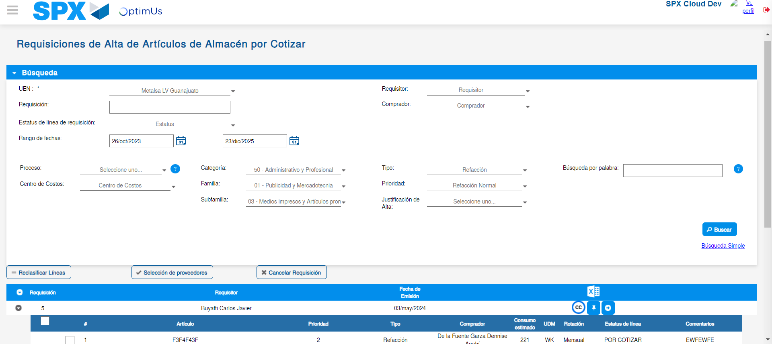Image file-name: QC_Testing-tc001_SPX_Dev5_Validar_Campos_Proceso_Nuevo_Articulos_Almacen-may. 16 2024, 06 55 28 p. m.

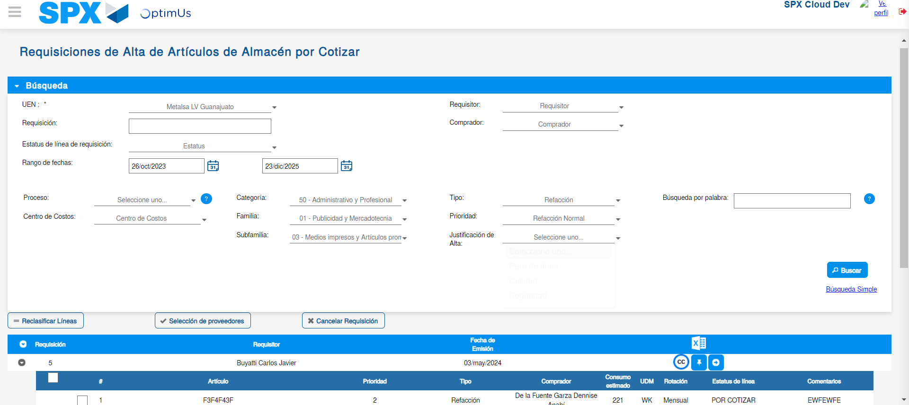Image file-name: QC_Testing-tc001_SPX_Dev5_Validar_Campos_Proceso_Nuevo_Articulos_Almacen-may. 16 2024, 06 55 32 p. m.

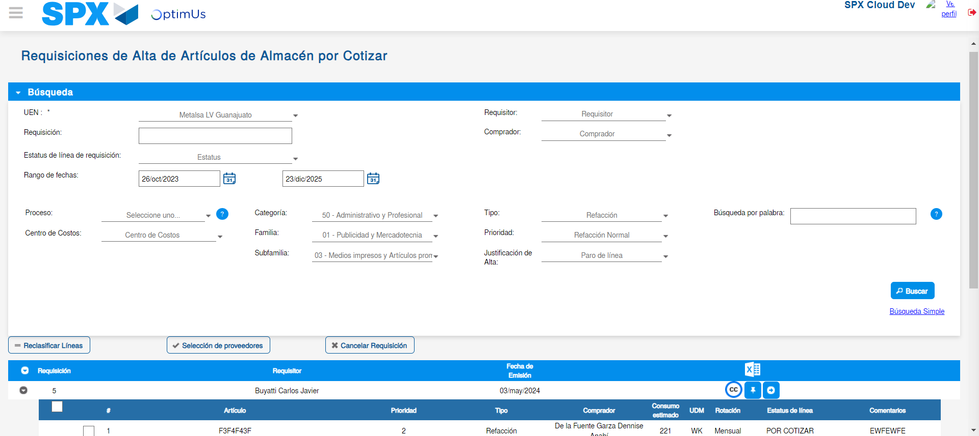Image file-name: QC_Testing-tc001_SPX_Dev5_Validar_Campos_Proceso_Nuevo_Articulos_Almacen-may. 16 2024, 06 55 33 p. m.

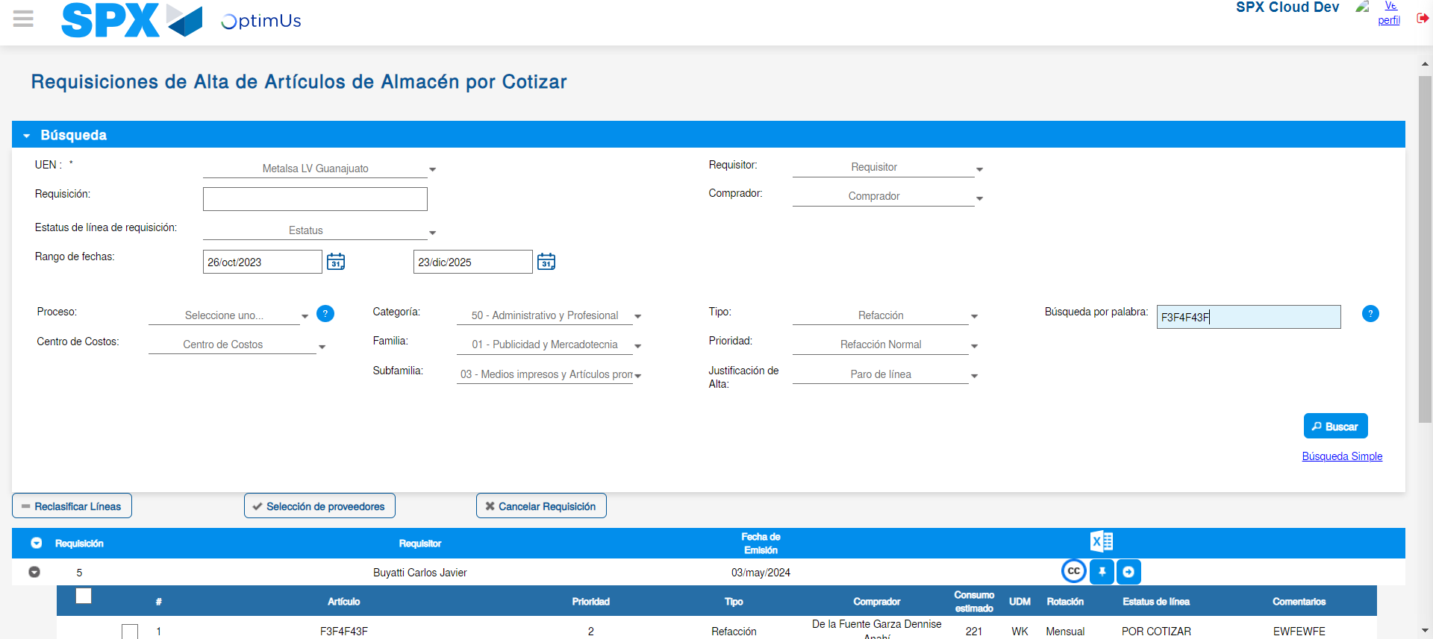Image file-name: QC_Testing-tc001_SPX_Dev5_Validar_Campos_Proceso_Nuevo_Articulos_Almacen-may. 16 2024, 06 55 36 p. m.

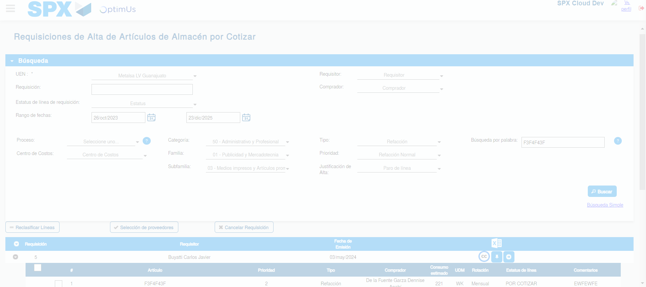Image file-name: QC_Testing-tc001_SPX_Dev5_Validar_Campos_Proceso_Nuevo_Articulos_Almacen-may. 16 2024, 06 55 40 p. m.

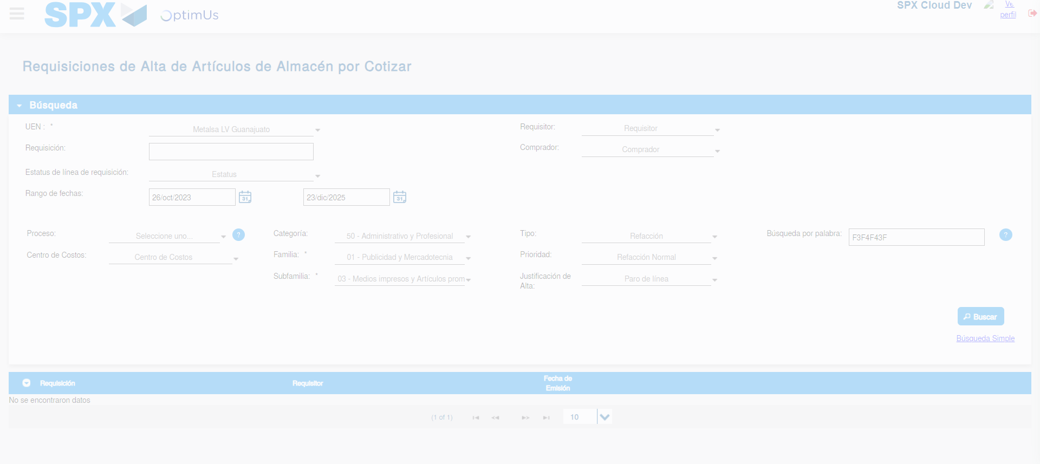Image file-name: QC_Testing-tc001_SPX_Dev5_Validar_Campos_Proceso_Nuevo_Articulos_Almacen-may. 16 2024, 06 55 43 p. m.

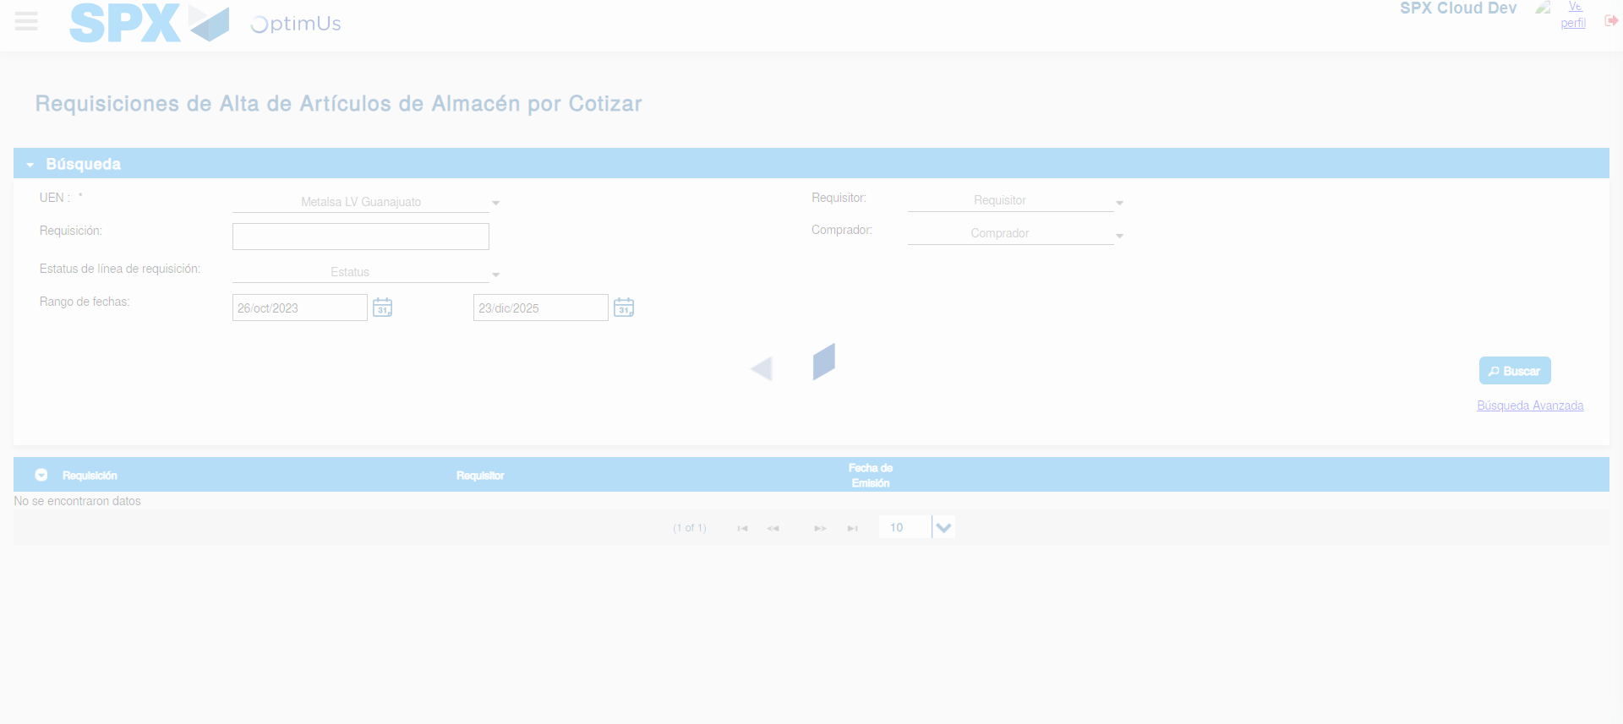Image file-name: QC_Testing-tc001_SPX_Dev5_Validar_Campos_Proceso_Nuevo_Articulos_Almacen-may. 16 2024, 06 55 44 p. m.

